Mercy Club  Meet-Ups Now at  Almost Home  Almost Home is located at 3310 Market St NE, Salem, OR, 97301, and the meeting will happen every Wednesday, excepting occasions Place is closed – Holidays or Special Events. For more info about The Mercy Club, or Meetings and Meet-Ups in general, call MERCY at: 503.363-4588 –or- visit:  www.MercyCenters.org |  | Mercy Club  Meet-Ups Now at  Almost Home  Almost Home is located at 3310 Market St NE, Salem, OR, 97301, and the meeting will happen every Wednesday, excepting occasions Place is closed – Holidays or Special Events. For more info about The Mercy Club, or Meetings and Meet-Ups in general, call MERCY at: 503.363-4588 –or- visit:  www.MercyCenters.org
Mercy Club  Meet-Ups Now at  Almost Home  Almost Home is located at 3310 Market St NE, Salem, OR, 97301, and the meeting will happen every Wednesday, excepting occasions Place is closed – Holidays or Special Events. For more info about The Mercy Club, or Meetings and Meet-Ups in general, call MERCY at: 503.363-4588 –or- visit:  www.MercyCenters.org |  | Mercy Club  Meet-Ups Now at  Almost Home  Almost Home is located at 3310 Market St NE, Salem, OR, 97301, and the meeting will happen every Wednesday, excepting occasions Place is closed – Holidays or Special Events. For more info about The Mercy Club, or Meetings and Meet-Ups in general, call MERCY at: 503.363-4588 –or- visit:  www.MercyCenters.org
Directions from Keizer (The Gathering Place, this example);  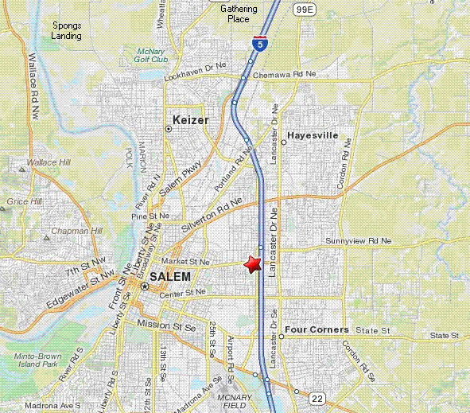  1: Start by turning LEFT out of the Gathering Place and go NORTHEAST on OR-219 toward QUINABY RD NE.  2: After 1.4 mi, Turn RIGHT onto BROOKLAKE RD NE.  3: After 0.7 mi, Merge onto I-5 S toward SALEM.  4: After 6.9 mi, Take the OR-213/MARKET ST. exit, EXIT 256, toward LANCASTER MALL.  5: After 0.3 mi, Take the ramp toward CITY CENTER.  6: After 0.1 mi, Turn SLIGHT RIGHT onto MARKET ST NE.  7: After 0.1 mi, 3310 MARKET ST NE is on the LEFT. |  | Directions from Keizer (The Gathering Place, this example);  1: Start by turning LEFT out of the Gathering Place and go NORTHEAST on OR-219 toward QUINABY RD NE.  2: After 1.4 mi, Turn RIGHT onto BROOKLAKE RD NE.  3: After 0.7 mi, Merge onto I-5 S toward SALEM.  4: After 6.9 mi, Take the OR-213/MARKET ST. exit, EXIT 256, toward LANCASTER MALL.  5: After 0.3 mi, Take the ramp toward CITY CENTER.  6: After 0.1 mi, Turn SLIGHT RIGHT onto MARKET ST NE.  7: After 0.1 mi, 3310 MARKET ST NE is on the LEFT.
Directions from Keizer (The Gathering Place, this example);  1: Start by turning LEFT out of the Gathering Place and go NORTHEAST on OR-219 toward QUINABY RD NE.  2: After 1.4 mi, Turn RIGHT onto BROOKLAKE RD NE.  3: After 0.7 mi, Merge onto I-5 S toward SALEM.  4: After 6.9 mi, Take the OR-213/MARKET ST. exit, EXIT 256, toward LANCASTER MALL.  5: After 0.3 mi, Take the ramp toward CITY CENTER.  6: After 0.1 mi, Turn SLIGHT RIGHT onto MARKET ST NE.  7: After 0.1 mi, 3310 MARKET ST NE is on the LEFT. |  | Directions from Keizer (The Gathering Place, this example);  1: Start by turning LEFT out of the Gathering Place and go NORTHEAST on OR-219 toward QUINABY RD NE.  2: After 1.4 mi, Turn RIGHT onto BROOKLAKE RD NE.  3: After 0.7 mi, Merge onto I-5 S toward SALEM.  4: After 6.9 mi, Take the OR-213/MARKET ST. exit, EXIT 256, toward LANCASTER MALL.  5: After 0.3 mi, Take the ramp toward CITY CENTER.  6: After 0.1 mi, Turn SLIGHT RIGHT onto MARKET ST NE.  7: After 0.1 mi, 3310 MARKET ST NE is on the LEFT.

