Marches for Global Cannabis Liberation

* High Noon * Saturday

May 1, 2010
Captiol Mall - Salem, Oregon and Hundreds of Cities around the World!
To raise awareness about cannabis as medicine, the value of industrial hemp and voter empowerment in general. This is about our rights and responsibilities as Americans. This is our opportunity to unite, stand together and be counted! * Every city in Oregon should be represented. Talk it up, be there and help make it happen! * For more detail, Visit: http://mercycenters.org/events/MMM.html
--------------------------------------------------------------------------------------------------------------------------------------------------------------
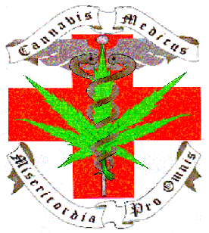
Join Up! * Contact MERCY - the Medical Cannabis Resource Center of Salem, Oregon * call: 503.363-4588 * eMail:

MERCY_Salem@hotmail.com

