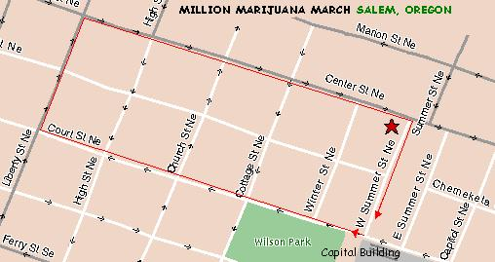
Salem, Oregon will be rallying and marching again this year (# 8).  Assemble starting at 11:00 at North end of Capital Mall Salem, Oregon on Sat., May 1st, 2010, we march at High Noon.  http://mercycenters.org/events/MMM.html | The Route:  W. Summer to Court,  Court to Liberty,  Liberty to Center,  and back to W. Summer (Mall)  Rally follows. | Contact:  MERCY Center  503.363-4588  email: MERCY_Salem@hotmail.com  or visit: www.MercyCenters.org

