Public Meeting so Medical Cannabis Patients and CareGivers can network
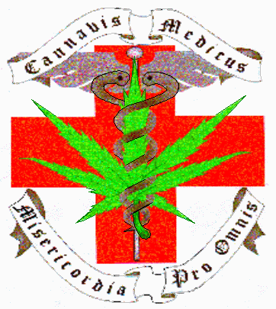
Announcing a meeting about the OMMP (Oregon Medical Marijuana Program), updating and educating CardHolders and Public on the Program and Medical Cannabis in general.

To be held at:
American Legion Building
1127 Long Street
Sweet Home, Ore., 97386

Monday, Dec. 4th, 2006

7PM to 9PM

Next ones happen

Mon. January 8th, 2007 and February 5th, and then

first Monday of the month from then on, all from 7PM to 9PM. some Agenda Items: Latest Patient and DPC (Caregivers) related News and Announcements; Current Happenings – within the Program, with the Legislature, with Advocates; How to? Forms and etc. - FAQS, Facts and the Issues; Helping people who (1) need a Doctor, (2) need Medicine, (3) Grow Classes, (3) Cooking Classes and such. Establishing tools for Networking: on-line and off – places to "bulletin board"? Also, GlassWare Parties combined with Voter Registration and L-T-E (Letters To the Editor) action item ideas - and more! * For more information contact MERCY – the Medical Cannabis Resource Center - by calling 503.363-4588 –or- visiting:

www.MercyCenters.org

