MERCYs Annual
Wake-n-Bake
Thursday, April 28th – Monday, May 2nd, 2011 (last week-end in April) * starts: whenever you get there * MERCYs 5th Annual Wake-n-Bake, a Camp Over and Pancake Breakfast * is to be held at the North Falls Group Camp, RV area B, at the Silver Falls State Park near Silverton, Oregon * We will be reserving the spot starting 4pm, Thursday, so folks can get there any time after that. Communing Friday afternoon and evening, a pancake breakfast Saturday morn 8am – 10am and Networking til 1pm, Monday. Medication Station for Patients. Letter writing, poster making and other activism. * for more info on the Camp, like directions,
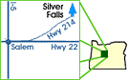
Silver Falls State Park is near Silverton
call: 503.873-8681, x23 –or- visit: http://mercycenters.org/events/Wake_n_Bake.htm * To reserve your spot or, for more on MERCY, call: 503.363-4588 –or- visit: www.MercyCenters.org

Help MERCY Help You and Others
MERCY – the Medical Cannabis Resource Center – is a 501c3 non-profit and your contributions are tax deductible as allowed by law. * If you want to help MERCY to do things like this or in general, Donations of $50 per person for 3-night stay or $75 per person for 5-night stay or even just $10/person + $5/car are suggested.
The Mission: Inform, Educate and Activate on and thru the Issue. The objective of the WaB is to establish a regular opportunity for networking or just getting out and away from the sick-bed for Medical Cannabis patients, their family & friends and like-minded people. At the same time it gives the Public a chance to come and mingle with members of the medical cannabis community and see that (a) their medicine is not evil and dangerous making them so and thus (b) they’re not monsters out to get their children.
A Strategy item: is to do this same place, same time every year so folks know when and where to find us and can plan accordingly. This will happen every year on the last week-end in April, so if you miss this years there's always the next.
Goal: to be just another node of the MERCY Event Network. MERCY is donating resources to help establish e-mail lists, phone-trees and other lines of communications dedicated to this action item - and anything remotely similar - in the region and beyond. Have your own, and let us know! Check our Calendar for others we're aware of.

Other items on the Agenda:
Legislative and Action items, changes to the Program - good, bad and otherwise. Activists plan next steps, local nad national.
We will be updating our members and attending public with current status, and actions items surrounding the issues effecting the medical cannabis community. We will be registering voters, distributing literature and networking ideas.
LTE. Need to keep up LTE's and generally promoting the needs expressed in the law. Also communicate to legislator in anticipation of upcoming action by prohibitionists and/or their lackey tools.
Another goal of the event is also to service:
People seeking to join the OMMP or public wanting general info, usually for a friend or family member.
Patients and CareGivers wanting to network. This is being planned in conjunction with other meetings and other lines of communication for the OOMPAH. (add link to meeting network and bulliten boards)
Activists exchanging information and resources.

About the North Falls Group Camps

Group camping at Silver Falls State Park means “circling” 25 RVs in one of two areas, or pitching tents to sleep up to 25 people in one of three areas. All five of the areas are reservable from April 1–October 31.

Although you’ll find ample space in the two RV areas, you won’t find sewer, electrical or water connections. However, the park’s RV dump station is located at the camp entrance.

Each of the group tent areas has picnic tables and outdoor fire pits. Water and restrooms (with flush toilets) are nearby.

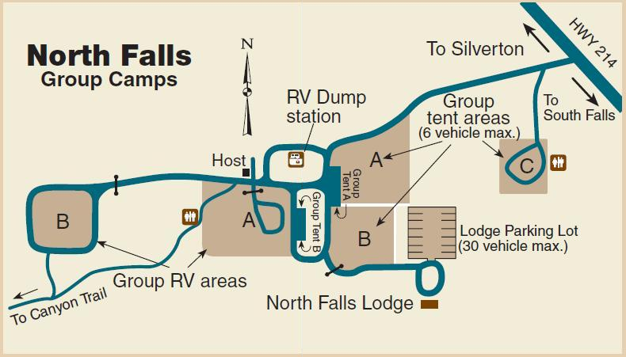

You can also reserve the North Falls Lodge for your group at any time of the year. The lodge has tables and seating for 100. Its modern kitchen is equipped with a large grill, oven and refrigerator/freezer.

