Calling all
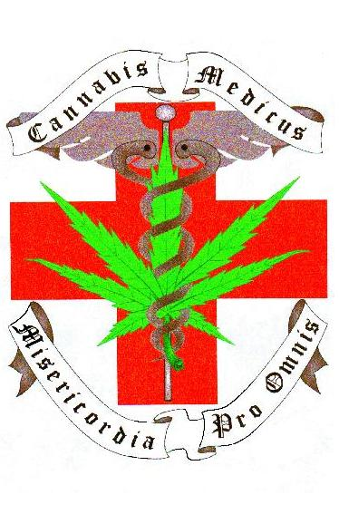
Patients, Caregivers
and OMMP Advocates!
The OMMP is being robbed of its registration fee surplus funds. There is over a million dollars in the OMMP Budget right now and the Joint Ways and Means Committee is trying to take $900,000 of it, calling an "emergency!" This will cause program fees to go back up!
There is a call for a peaceful rally to show discontent with HB 5077. The rally will be at the Oregon State Capitol on the front steps on Wednesday, June 1st, 2005 at 10:00 am. Press releases are being sent out and there is hope of gaining positive media coverage at the event.
There will have signs available, speakers (TBA), and a STRONG VOICE as a GROUP to object to HB5077. Join it. There is also a hearing on Senate Bill 772 scheduled for Wednesday in the afternoon.
Please dress conservatively (you represent all those that couldn't make it. You're their rep!), keep in mind that this is a peaceful, non-smoking rally - and remember your sunscreen and bumpershoots.
Social gathering to follow at Lefty's Pizzeria on State Street in Salem. Time: TBA

Your presence is necessary! We need to stop this bad legislation from happening! If you need a ride from the Portland area, you can meet up at Pho's between 8:15 am-8:40 am, (traffic!!) but please contact Schorts or Big Stevo first to confirm your spot!
Organized by Trista Okel of Oregon Green Free. For more info go to - OregonGreenFree.com or contact by phone at: (503) 569-3002
OMMP PATIENTS RALLY TO OPPOSE HB 5077
And Celebrate that Money from Marijuana can Help the State

Medical Marijuana patients and advocates will be gathering on the steps of the Oregon State Capitol in Salem to announce to Legislators and the people of Oregon, both our disappointment at our medical marijuana registry permit fund being raided as well as our pride in being able to help in the DHS 2005 rebalancing of its budget with monies derived from the state’s medical marijuana registry program.

“We realize that there is a budget crisis in this state and that the OMMP has a surplus of funds comprised of patient registration fees. As long as this doesn’t cause patient registration fees to rise, which would create a hardship for thousands of sick Oregonians, we are glad to share the money derived from the state’s medical marijuana registry permit program with the general fund,” says Trista Okel, OMMP patient and advocate.

House Bill 5077 may hurt a program which has helped thousands of Oregon’s sick and suffering citizens. We have created an unprecedented model in which Law Enforcement, Legislators, Doctors, Patients, Caregivers and Legal Advisors have come together to write a bill that creates a program which works for all of us.(SB 772)Please join medical marijuana patients and advocates at our rally on the steps of the Capitol with speakers to include attorney and advocate Leland Berger, Jim Klahr of the patient advocacy group Oregon Green Free, as well as other community leaders and OMMP patients.

WHERE: Oregon State Capitol, Salem (front steps)
WHEN: Wednesday, June 1, 2005, 10:00a.m.
Contact: Trista Okel, 503-569-3002

