MERCY sign up sheet. Get newsletters, stay in the loop. 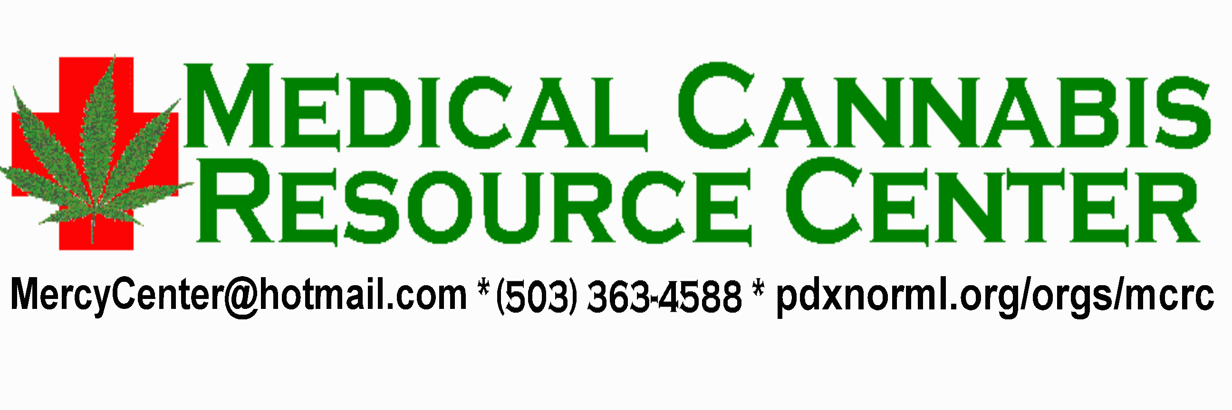

Name | Address | Phone | Email
MERCY - the Medical Cannabis Resource Center * 1675 Fairgrounds Rd., Salem, Oregon, 97303 *
503-363-4588 * E-mail: MercyCenter@hotmail.com * WEB page: www. MercyCenters.org

