
People of All Kinds Rally for Global Cannabis Liberation
The 2008 Million Marijuana Marches Happen In Salem, Oregon and Around the World  For ultra-conservative, small-town Salem, it was a big turn-out, put the official number at 40. Lots of networking on medical cannabis – as the folks from MERCY were organizing it – as well as other NORML goals of hemp and ending prohibition in general. A good action item and the best Million Marijuana March in MERCYs now six-year history of organizing them in Salem. They look forward to building up to next years event with poster parties and such, culminating in every one of last years participants bringing at least one  _____________________________________________  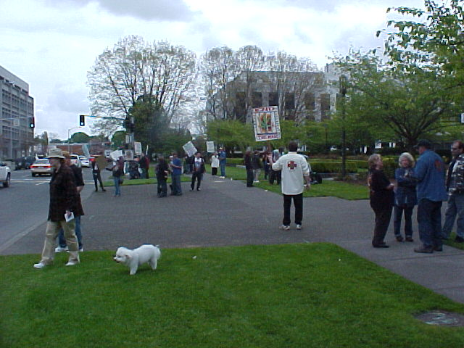  Assembly for the 2008 Salem MMM starts at 11:00am, Saturday, May 5th, 2008, at the “corner” of W. Summer and Center streets, at the far end of the Mall from the Capital Steps. | other with them for 2009. Wednesdays at the Coffeehouse Café in Salem at 7pm, is a good starting point.  The Million Marijuana March is an annual global event celebrating the benefits of cannabis and hemp that takes place, for most participants, on the first Saturday in May. On that day – referred to as Jay Day by some organizers – people in hundreds of cities around the world rally and march in unison for cannabis law reform. A peaceful party to celebrate our gains and to re-energize for the next steps. The main purpose is to raise awareness about the issues, to inform and educate thru the publicity involved. Secondly, we want to register every person there and further empower them by providing whatever is needed to getting them to the voting booth at the right time. Also we want a good show, a nice time for every one - entertaining as well as informative. And, at the same time, we can also raise a little money and fund some projects for the cause - like sponsoring OMMA patients who can't afford a fee or a Hemp Initiative. We pick up steam every day, we gain more sponsor$ and other support each time we talk about it.  Also, different groups with related agendas can be represented. We can use this opportunity to stand united as one voice.  Next is May 2nd, 2009. In Salem, they will  < continued pg 5 >

* Special Edition * MMM * 2008 * www.MercyCenters.org *

* The MERCY News *
The MERCY News Report is an all-volunteer, not-for-profit project to record and broadcast news, announcements and information about medical cannabis.  For more information about the MERCY News Report, contact us.  Snail Mail:  The MERCY News Report  P.O. Box 1111,  Cornelius, Ore., 97113  503.363-4588  E-mail:  Mercy_Salem@hotmail.com  our WWW page:  www.MercyCenters.org  Check it out!  ___________________________    Pioneering Common Sense Compassion throughout Oregon, across America and around the World.  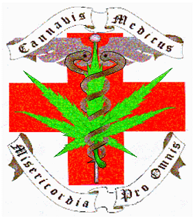 | About MERCY  MERCY is a not-for-profit, grass roots organization founded by patients, their friends and family and other compassionate and concerned citizens in the area and is dedicated to helping and advocating for those involved with the Oregon Medical Marijuana Program (OMMP). MERCY is based in the Salem, Oregon area and staffed on a volunteer basis.  The purpose is to get medicine to patients in the short-term while working with them to establish their own independent sources. To this end we provide, among other things, ongoing education to people and groups organizing clinics and other Patinet Resources, individual physicians and other healthcare providers about the OMMP, cannabis as medicine and doctor rights in general.  MERCY wants to be a strong patient advocate, which can manifest itself in a variety of ways. One of these has been maintaining lines of communication with other patient advocates and the OMMP director and workers, which we are trying to do.. At the same time we attempt Doctor education and support programs, and Patient and Caregiver projects like learning to grow and different methods for consumption. These are especially important for the first time medical cannabis user as well as those unable to apply their medication.  The mission of the organization is to help people and change the laws. We advocate reasonable, fair and effective marijuana laws and policies, and strive to educate, register and empower voters to implement such policies. Our philosophy is one of teaching people to fish, rather than being dependent upon others. Lasting change will require that each citizen be active enough to register and effectively vote. You, and only you, the people, can make it happen. We will help in any way we can, but you have to tell us what you need. Work with us to make this your "tool shed", or resource guide, to successful medical cannabis utilization and activism.  Monthly Meetings and Office Hours  Networks and Meet-Ups; Patients in the ‘Hood. One of the missions of MERCY is to establish regular get-togethers in each community where the are (or will be!) medical cannabis patients. The purpose is to get patients networking and self-sufficient within their neighborhoods, assist those seeking information about the OMMP and pass on (or pick up!) action items of interest to the group. Regular meetings are being established in places like Sweet Home, Bend and around the state. MERCY will continue to help make them happen and network folks to them.  Meetings on the Last Thursday of the Month in Salem. To update folks with current status and action items surrounding the issues affecting the medical cannabis community as well as registering voters, distributing literature and networking ideas.  < continued next page >
2 mercycenter@hotmail.com *

Volume 5, Issue 1 * Spring * 2008
< continued from previous page > The goal of the meetings is to service:  * People seeking to join the OMMP or public wanting general info, usually for a friend or family member.  * Patients and CareGivers wanting to network. This is being planned in conjunction with other meetings and other lines of communication for the OOMPAH. (add link to meeting network and bulletin boards)  * Activists exchanging information and resources.  We Still Need an Office Place. The community needs a place in the Salem area to assist people in getting into the OMMP as well as helping them find access to excess medicine. Through the above actions, MERCY intends to build a volunteer base for constant recruitment & administration of the organization for the future. Through marketing and communications we hope to coordinate with business and organizations to make a lasting, positive change in the community.  Please help us help the sick and dying, For more info or If you have any information or ideas, please let us know. Contact MERCY - the Medical Cannabis Resource Center by phone: 503.363-4588 or email: info@mercycenters.org  ___________________________  MERCY on the Tube  Mercy TV is shown on cable in the Salem, Oregon area thru Capital Community Television, Channel 23. See it TUE @ 10:30pm, THU @ 2:00pm, FRI @ 11:30am -or- SAT @ 8:30pm.  _________________________________________  <continued from “THE MARCH”, pg 1> start at 11am - Assemble, Rally and March at High Noon as part of this action item, at the far end of the mall across from the steps of the Capital Building.  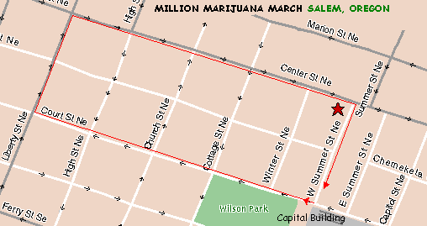 | 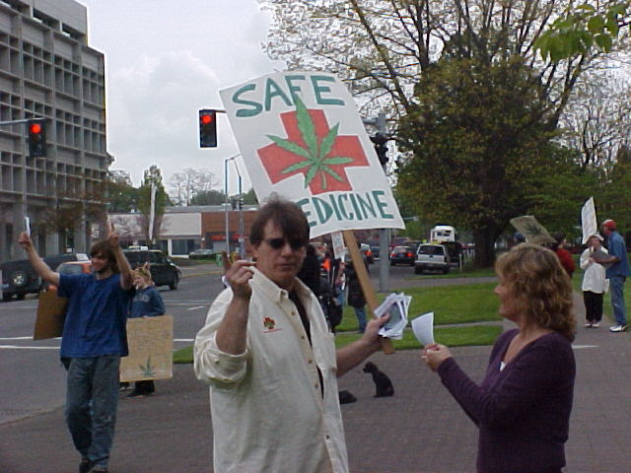  Marchers had out flyers to passer-bys, recruiting more marchers and demonstrating to folks driving by.  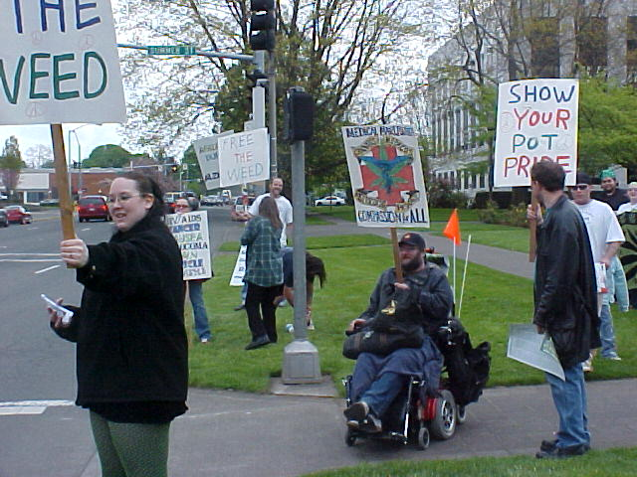  ___________________________________________  At High Noon (sharp!) they proceed down W. Summer thru the Mall to the corner of W. Summer and Court. Then west down Court Street on the north side-walk. They most likely will not have permission ($!) to use the street, so must stick to the sidewalks and obey pedestrian rules. They will check on being able to have bicycles and pace vehicles on the street beside them. They’ll be sure to not block traffic or impede other citizens attempting to use the walkway. They’ll march, proudly, politely and peacefully, down to Liberty Street and turn right. Then go north up Liberty to Center and turn right. Going east down Center Marchers will come to W. Summer (the Mall), returning to their original rally point. Those unable to go the distance will be holding the Assembly point and waiting for the Marchers there. Then a post-March Rally at Wilson Park. See directions at  mercycenters.org/events/MMM.html
503.363-4588 * www.MercyCenters.org 3

* The MERCY News *
< continued from previous page > In 2008, during assembly, an Oregon State Trooper showed up due to a report he received about a Smoking March that was happening. We informed him that we weren’t prepared for or planning any acts of civil disobedience this occasion and educated him on the March strategies, goals and objectives in general. We then had an interesting exchange as we commented on whether or not Patients would be medicating and the issue of public view. He made a statement to the effect that if Patients were walking along smoking, it would be a “gray area”. An interesting viewpoint we had no intention of testing this year.  Our purpose is to rally, register to vote, sign petitions and encourage everybody we know to do so also. The goal is to allow individuals to come out and – by doing so - make a statement in the company of like minded citizens. Share, learn and grow as we promote ending cannabis prohibition - and freedom in general. This is to raise awareness about cannabis as medicine, the value of industrial hemp and voter empowerment in general. This is about our rights and responsibilities as Americans. This is our opportunity to unite, stand together and be counted! Every city in Oregon should be represented. Talk it up, be there and help make it happen!  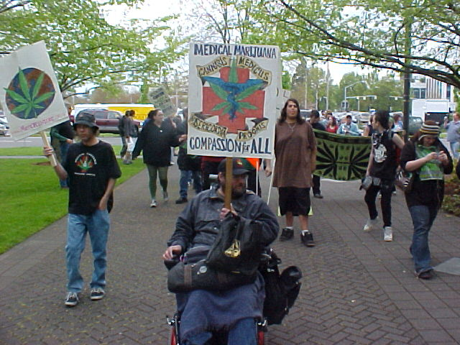  The March starts down W. Summer, the “alley” on the west side of the Capital Mall. | 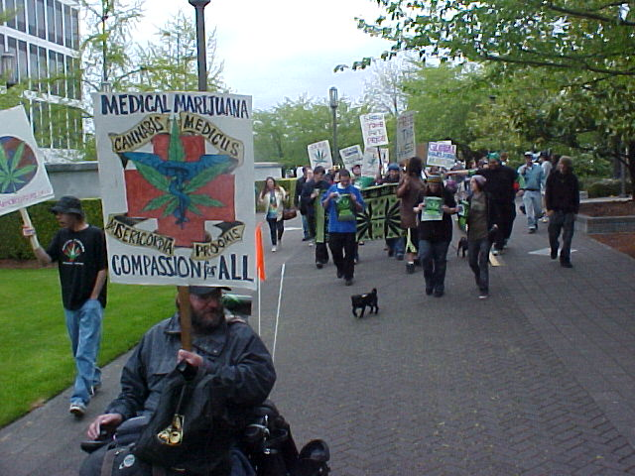  The March proceeds to Court street from assembly point on Center street.  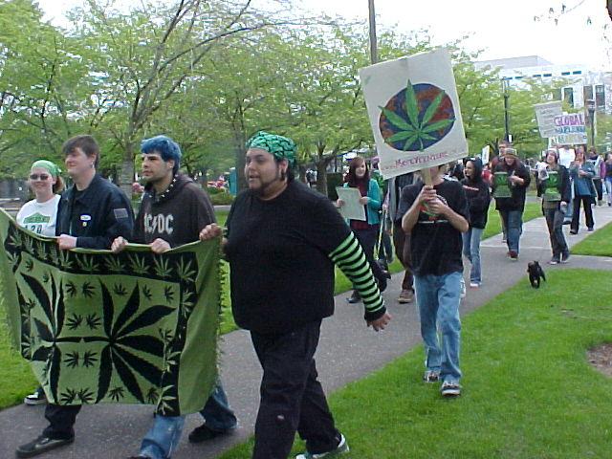  Salem MMMarchers turn onto Court street.  ______________________________________  Mission objectives & goals: Register to vote, sign petitions, and encourage everybody we know to do so also.  (1) the March (and thru publicity about & during the March raise awareness and followers)  (2) Registering Voters (thru the Rally) and …  (3) signing any petitions available at the time …  (4) empowering (tools & tool building 'kits') them thru Literature and Contact info. Thru that we …  (5) sign up contacts and generally gain support & We do this for the cause in general and to get the most resources to best insure we …  (6) fundrai$e. ('cheap, good, on time' paradigm)  (!) and, at the same time, build alliances and network to an overall activist community.
4 mercycenter@hotmail.com *

Volume 5, Issue 1 * Spring * 2008
Strategy issues:  (1) Family Affair  (2) Accentuate the positives, 'information stations' at all four corners  (3) communications, volunteer training  (4) know our rights and options - can squads of cops just stroll on thru with frothing dobermans and loiter at leisure? (not that we object, heck give them the mike!)  In 2008, the Marchers are not able to take to the streets due to the prohibitive costs the Salem police put on escort and “security” needs. So we use the side-walks … in batches. This year, for the first time, They had the wonderful problem of being too long and needing to wait for the end to catch up before crossing streets.  _________________________________________  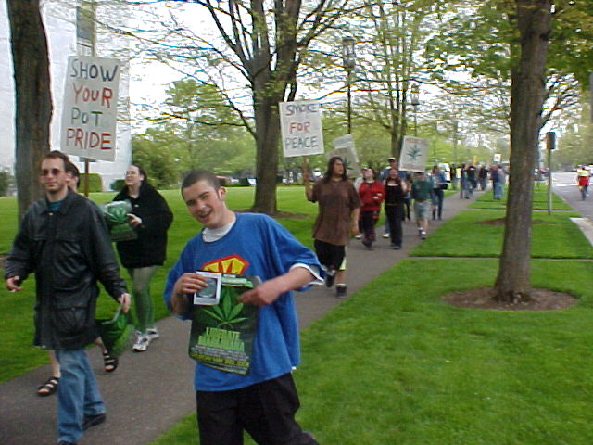  Salem MMM Marchers parading down Court street on the side-walk. Drive-bys continue to show support with honks, thumbs-up and various shouts of encouragement.  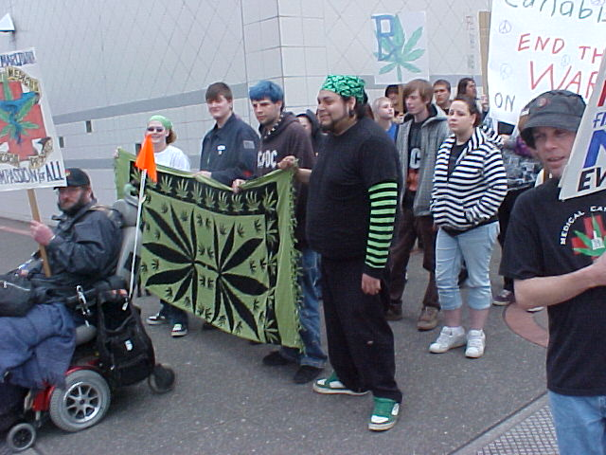 | 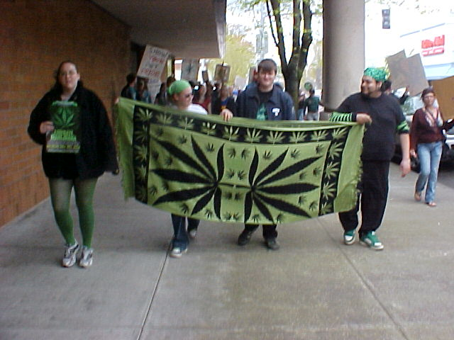  The March continues down Court to Liberty in downtown Salem, Oregon.  _________________________________  SOME HISTORY  The MMM is an event that has been going on for somewhere around 25+ years and has years of tradition of which many are unaware. It started as the Yippie! organized "May Day 5th Avenue Pot Pride Parade" in New York City and in 1996 became known as the Million Marijuana March. Even though the event still occurs on the first Saturday in May, it has now established tradition of its own, spreading beyond NYC.  The emphasis of the following years events are turning from that street party into a productive political venue that the NAACP and the ACLU would be proud to co-sponsor. We folks in Salem are doing this successfully, we believe. Let's honor our counter-cultural elements, history, heroes and activists, but at the same time be aware that we need to better coordinate our efforts for the maximum politically-positive media spin and potential resulting benefits for our on-going political efforts.  Ours are not the minds we need to be concerned with. Its success depends on our ability, each and every one of us, to become a teacher.
503.363-4588 * www.MercyCenters.org 5

* The MERCY News *
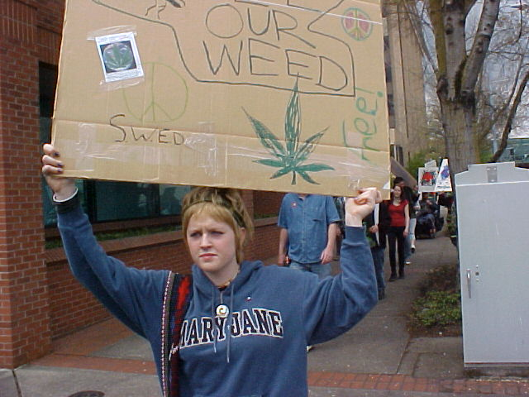  Drive by networking. For the 2008 March in Salem, Sign making material was on hand and last minute attendees were able to make effective signage there and then. It didn’t need to be a perfect presentation, the message was simple and getting out, as evidenced by the response from drivers. The “Honk For Hemp” on the back of the above example got a lot of “votes” from driver-bys. A notable unsolicited observation was the broad spectrum of society showing support. “Man, what a variety of people. There was folks of all colors, old and young, rich and poor looking [cars], soccer-mom’s with vans full of kids and hard-hats on their way to a job” commented one participant.  Poster parties leading up to next years March anyone? See you at the Café!  Carrying placards and signs and wearing T-shirts that show off well on TV. The media should be interviewing patients and well spoken representatives of the MMJ movement. That big red cross with a green leaf "Healing for Patients" clearly in big letters,or something similar. Some may want to carry large blowups of patients they are representing that day.  Spread The Word! Wherever two or more of the faith are gathered or likely to. Tell your friends and families. Tell all the MMJ and MJ forums that you are on. Post it on ANY web site that will allow you to. | If you can't make it to one of the cities listed, stand in front of your local city hall, LEO, court house, parks and show your support for this. Register Voters and Collect signatures in your home town as you educate locally on this event and the issue. If there is a street fair, try to get a Booth that will be up for that weekend. utilize the media to the maximum. Most small town newpapers and even Time magazine do not cover this issue enough. Few are expressing OUR ideals and success stories. Fill the Letters to the EDITORS on all venues that this is happening and your opinions and positive testaments on it.  One strategy is that sick people be forefront in this show of strength. The focus chould be on the ill and the benefits MMJ has brought to them. Wrap your heads in bandages and arms in slings so the media will have this in the FRONT PAGES and to show your support. Wrapping in bandages it is a symbolic gesture to show support for the Medical Cannabis agenda and Theatrical expression is a magnificent part of effective protesting. Just as many people supported Ghandi by wearing handspun cotton and MLK Jr by peaceful demonstrations. Respectful non-violent demonstration worked for GHANDI and MARTIN LUTHER KING JR and it can change the world.  Be the BEST that we < continued next page >  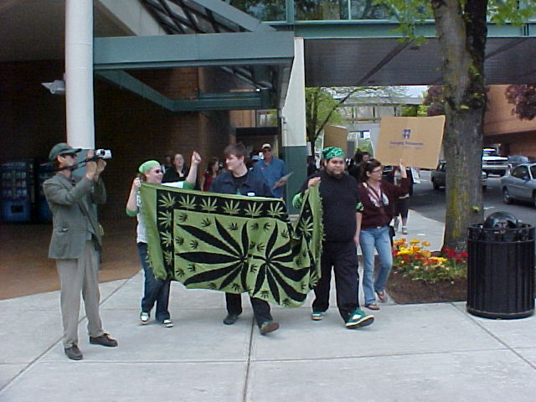  Marchers stopped at major intersections to demonstrate to drivers and passer-bys, getting a over-whelming positive response.
6 mercycenter@hotmail.com *

Volume 5, Issue 1 * Spring * 2008
< continued from previous page > can to bring these compassionate needs to the public eye. Work to change the LIES that perpetuate the Drug War Propaganda. Change the TERRORISM the government inflicts on citizens and families because of a plant with the beneficial properties that MJ has had for a millennium or more.  Urge everyone who participates not to publicly do anything to disrespect the movement. Certainly no violence and any pot-smoking, especially by “kids”, will be EXTREMELY detrimental and counter-productive.  Bring out those who will sign petitions and vote and those that are riding the top of the fences. The purpose is to encourage individuals to come out and make a statement in the company of like minded individuals. Share, learn and grow as we promote ending cannabis prohibition - and freedom in  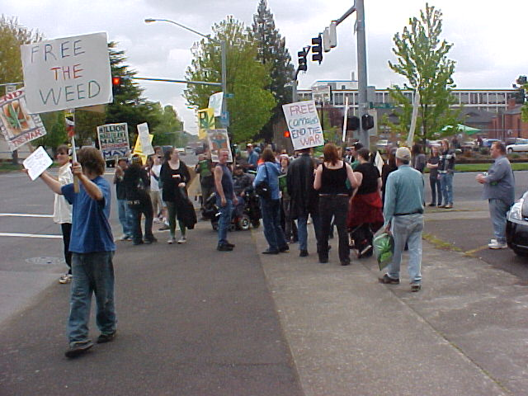  The March continues from Liberty up Center street  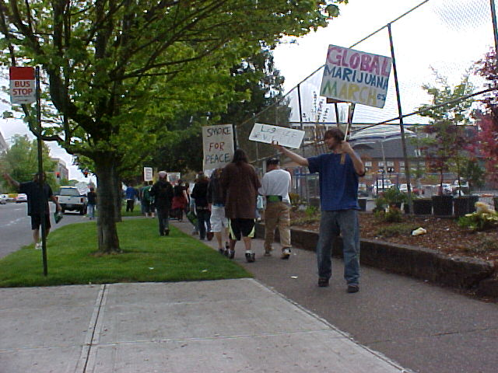  … back to the assembly point at W. Summer. | general. Talk it up, be there and help make it happen!  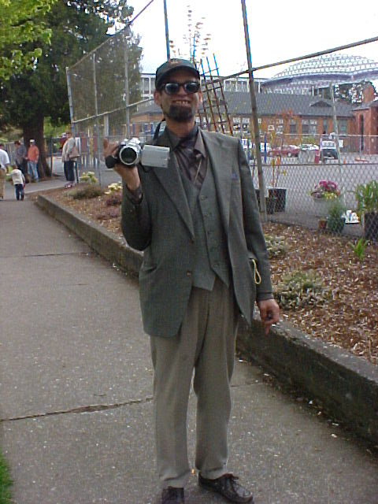  Local media was represented by MERCY-TVs P.K. Kramyer. Footage of the March can be seen in the Salem-area on cable at Capital City TV’s channel 23 on TUE @ 10:30 pm, THU @ 2 pm, FRI @ 11:30 am -or- SAT @ 8:30 pm.  ___________________________________________  Other 2008 Million Marijuana Marching in the Northwest  Abbotsford: Tim Felger * tfelger@telus.net 604-851-5777 * About CEO, Matt Monarch  Anchorage: Iyana or Katrina Dall * hkd_id@yahoo.com * 907 339 2333  Bend: Christine Belmont <Crazyinbend@msn.com>  Boise: Rev Tom Hayes (208) 384-1421 * org: Musicians & Entertainers Helping End Marijuana Prohibition MEHEMP@aol.com * www.mehemp.tv *  5645 Woodcross Dr., Boise, Idaho 83716  May 3 Rally starts at 2PM Julia Davis Park entrance on Capitol blvd. March begins 4PM. to the statehouse steps, at 4:20 guest speakers.. Be there or Be Square!!!  < continued next page >
503.363-4588 * www.MercyCenters.org 7

Other 2008 Million Marijuana Marching in the Northwest  Portland: 503.239.6110 http://www.ornorml.org 2005 GMM Organizing Committee, c/o Oregon NORML, PO Box 16057, Portland, Or 97292-0057 Alicia Williamson projects@ornorml.org 503-985-7704 [PO Box 31,Gaston, OR 97119] or Madeline Martinez: yerbanena@hotmail.com * or exec.director@ornorml.org * or secretary@ornorml.org 350 in '07! March from Pioneer Courthouse Square.  Eugene: Jim Greig specialprojects@willamettevalleynorml.org 541 607 3990 cell: 562 774 6034 or Kris Millegan <Hempsters@aol.com> 800-556-2012 P.O. Box 577, Walterville, OR 97489  Fairbanks: Sandra Greenstreet honey_086@hotmail.com (907)322-4645  Juneau: Xandi Sanchez xtcsalescad.com 907-586-6688 Xandi's Treasure Chest, 209 Seward St, Juneau, AK 99801  Missoula: Freedom Fighter <missoulamjmarch@yahoo.com> [c/o Angela Goodhope, 110 Vine St., Missoula, MT 59802] or Montana NORML norml@montananorml.com  Olympia: Kathy Parkins kathymerry@yahoo.com 360-584-9021 [6001 Pennsylvania St, Olympis,WA 98513] Statehouse Rally  Seattle: Joanna McKee 206-762-0630 Green Cross, 8843 10th Ave SW, Seattle, WA 98106 or Zeb 425-761-12222228763 [18463 Blueberry Lane M202, Monroe, WA 98272] Volunteer Park to Pioneer Sq., noon to 2pm.  Spokane: Darren McCrea 509-998-3405 president@rcannabisclub.org [4807 N. Adams, Spokane, WA 99205] http://www.SpoCannabis.com | Tacoma: Aron Khenderson@harbornet.com 253-678-6635 [8426 Takoma Ave South, Takoma, WA 98444] March from Courthouse, high noon  Yakima, WA: Sylvia * fatal_juggalette420@hotmail.com * 509-576-4206  Castlegar: ogrimdoomhammer999@hotmail.com crack_kills420@hotmail.com or call 365-3330 March begins in Kinnard Park, Castlegar, B.C. 1:00 PM Live band Lithium  Vancouver: David Malmo-Levine davidml@telus.net Tel 604-682-1172, www.cannabisculture.com/march c/o BC Marijuana Party Bookstore and Internet Broadcasting Center, 307 West Hastings, V6B 1H6  ___________________________________________  Important: get your city on the list for the Global Marijuana March, May 2, 2009! If you’d like your action item to be listed on the poster, or organizer Cures-Not-Wars webpage, etc., or talk to them about the event, please contact them by  phone (212-677-7180) or email (dana@cures-not-wars.org) or website ( http://www.cures-not-wars.org ) and specify that your group has decided to do a march, rally, forum, vigil, festival or other pro-cannabis event in conjunction with Global Marijuana Day. Even if you were listed in 2008, if you do not contact them by email or other, they may not list you. Bad experiences due to listing cities wholesale without their explicit authorization have convinced them that new, updated commitments are necessary for every participating location.  Please be sure to update emails, phone numbers, website and postal address--and supply local contact person info if possible. If you cannot do it on the first Saturday in May --if for instance you or anyone you know in another city is doing something around 4/20, or in early June-- that's fine, just let them know your alternative date, so they can put it on their website and other media.
* The MERCY News > mercycenter@hotmail.com > (503) 363-4588 < www.MercyCenters.org *

