
Suffer The Little Children, Medical Cannabis For Kids Too
Joey's Journey: Medical Marijuana Saves Child's Life  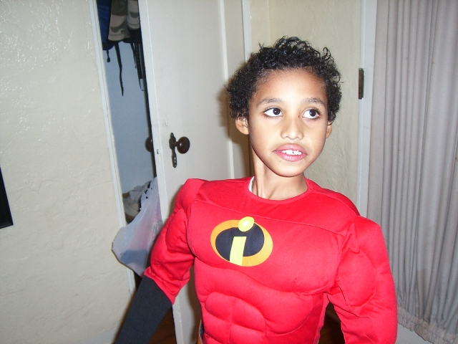  Knocking on deaths door, 10 year old Joey Perez was slowly dying. The potpourri of prescription medications he’d consumed since the age of 5 were damaging his body beyond repair. The side effects were literally killing him. Doctors had no answers, or any safe alternatives. Their only suggestion was the combination of a few more meds, and to experiment with what happened next. Mieko, Joeys mother, knew his body was weak and shutting down. She knew his fragile body could not handle the addition of any more toxic medicines. Luckily for Joey, her experience as a legal researcher gave her the tools she needed to  <continued on page 3 > | Crime Of The Century, Man Puinished For Helping 6-Year Old Girl with Brain Cancer  Medical Marijuana Advocates Protest Latest DEA Raids in Michigan and California  SAGINAW, Mich./ SAN DIEGO - Coordinated and lively protests were carried out today (July 21, 2010) by medical marijuana patient advocates in both Saginaw, Michigan, and San Diego, California, against the federal Drug Enforcement Administration (DEA) for several raids it conducted earlier this month, despite a Justice Department policy issued in October 2009 discouraging such raids. The Michigan Medical Marijuana Association organized the Saginaw protest march and Americans for Safe Access organized a rally at the federal courthouse in San Diego.  On July 6th, the DEA raided John Roberts and Stephanie Whisman, two licensed medical marijuana caregivers from Thomas Township, MI. Then, the next day, on July 7th, the DEA raided the Covelo, CA home of Joy Greenfield, the first collective to apply for the Mendocino County Sheriff's  <continued on page 14 > | Medical Marijuana For Children:  New Trend In Alternative Medicine  Medical Marijuana Touted as Viable Option For Treating OCD, Autism and Other Ailments In Kids  Medical marijuana (cannabis), which is legally available in 14 states with a prescription, is used everyday by millions for a variety of ailments. Many adults turn to the controversial drug (as it is illegal in most parts of the United States) to treat cancer side effects, fibryomyalgia, migraines, anxiety - the list is endless. But one mother has made a provocative public admission: she is administering medical marijuana to her 11-year-old son, Ryan Mendoza. The boy suffers from a rare genetic disorder, called PANDAS, which causes severe Obsessive Compulsive Disorder (OCD), among other ailments.  Judy Mendoza considered the controversial treatment after hearing of another mom's success story with the drug. The other family, who appeared  <continued on page 14 >

* Volume 7, Issue 7 * July * 2010 * www.MercyCenters.org *

* The MERCY News *
_____________________  The MERCY News Report is an all-volunteer, not-for-profit project to record and broadcast news, announcements and information about medical cannabis in Oregon, across America and around the World.  For more information about the MERCY News, contact us.  Via Snail Mail:  The MERCY News  1469 Capital St. NE, Suite 100,  Salem, Ore., 97301  503.363-4588  E-mail:  Mercy_Salem@hotmail.com  Or our WWW page:  www.MercyCenters.org  Check it out!  ___________________________  MERCY On The Tube!    in Salem, Oregon area thru Capital Community Television, Channel 23. See us on Wednesdays at 06:30pm, Thursdays at 07:00pm, Fridays at 10:30pm and Saturdays at 06:00pm. Visit –  http://mercycenters.org/tv/ | About MERCY – The Medical Cannabis Resource Center  MERCY is a not-for-profit, grass roots organization founded by patients, their friends and family and other compassionate and concerned citizens in the area and is dedicated to helping and advocating for those involved with the Oregon Medical Marijuana Program (OMMP). MERCY is based in the Salem, Oregon area and staffed on a volunteer basis.  The purpose is to get medicine to patients in the short-term while working with them to establish their own independent sources. To this end we provide, among other things, ongoing education to people and groups organizing clinics and other Patient Resources, individual physicians and other healthcare providers about the OMMP, cannabis as medicine and doctor rights in general.  The mission of the organization is to help people and change the laws. We advocate reasonable, fair and effective marijuana laws and policies, and strive to educate, register and empower voters to implement such policies. Our philosophy is one of teaching people to fish, rather than being dependent upon others. Lasting change will require that each citizen be active enough to register and effectively vote. You, and only you, the people, can make it happen. Work with us to make this your resource guide and all-around "tool shed" to successful medical cannabis utilization and activism.  * Want To Get Your Card? MERCY is hosting Medical Cannabis Consultations in Salem. Please call 503-363-4588 or email – info@mercycenters.org - to begin the process of transferring records and scheduling an appointment.  Meetings and Meet-Ups  * Every Wednesday (except Holidays), 7:00pm to 9:00pm * CardHolders MeetUp hosted by MERCY at The Almost Home restaurant in Salem. Located at 3310 Market St. NE, Salem, Oregon, 97301, This one will happen every Wednesday. * for more info, call MERCY at: 503.363-4588 –or- visit:  mercycenters.org/events/AlmostHome.htm  Other Medical Cannabis Resource NetWork Opportunities for Patients as well as CardHolders-to-be. * whether Social meeting, Open to public –or- Cardholders Only * visit: mercycenters.org/events/Meets.html ! Also Forums - a means to communicate and network on medical cannabis in Portland across Oregon and around the world. A list of Forums, Chat Rooms, Bulletin Boards and other Online Resources for the Medical Cannabis Patient, CareGiver, Family Member, Patient-to-Be and Other Interested Parties. * Resources > Patients (plus) > Online > Forums * Know any? Let everybody else know! Visit: mercycenters.org/orgs/Forums.html and Post It!
2 mercycenter@hotmail.com *

Volume 7, Issue 7 * July * 2010
<continued from JOEY’s JOURNEY, page 1 > start her and Joey on this journey. A healing journey with an effective treatment - Medical Marijuana.  Joey was diagnosed with Autism at 18 months old. His mother, Mieko has been fighting that battle ever since. Her life is not consumed with why Joey has Autism, she now focuses on what she can do to effectively treat her sons condition.  Mieko was taking the advice of her doctors, and experimenting with a slew of different prescriptions for her severely autistic son. At one time, Joey was taking 6 different medications - up to 3 times a day. As a result of the side effects, Joey became malnourished and was diagnosed with Anorexia. Every day, his condition got worse. He was deteriorating in front of his mothers eyes. Joey clearly showed all the signs that he was starving. Besides being under weight and malnourished, Joeys eyes were sunk in and you could easily see all the bones in his chest. He was refusing to eat. Even the costume of a buff super hero could not disguise the starved body underneath. All of Joeys family and friends were helplessly watching him die.  Then Mieko received the most dreaded news a parent could ever hear. Joeys medical prognosis at that time was high probability of death within 6 months. She and her husband Eric were devastated. With the thought of him dying, she clung on to him tightly, and prayed for a breakthrough. Joey needed a miracle to occur.  Mieko believes through a divine intervention she found the research of Dr. Bernard Rimland, founder of the Autism Research Institute.  Mieko gathered research and studies and armed herself with tons of compelling evidence of the benefits of Medical Marijuana. She then presented it to Joeys doctor. Joeys doctor agreed that this option might help, and she wrote Joey a recommendation for Medical Marijuana. Doctors may not prescribe marijuana for medical use under federal law, though they can recommend its use under the First Amendment.  That was eight months ago. Today - Joey is thriving. His improvements go above and beyond anything Mieko could have ever imagined.  Mieko believes Joey IS the research that is needed and that his success with Medical Marijuana proves the Compassionate Use of Medical Marijuana SAVED HER SONS LIFE!  “Although Medical Marijuana is not known to be a cure for Autism, It has been proven to facilitate | "Life" for my son; and has ushered him into his most progressive developmental period ever.  Today, at age 11, Joey is flourishing with new communicative expressions, he's gained over 40 lbs, he's happier, healthier, better behaved & is more productively active than ever before. My son has made so many PROFOUND improvements with the help of MMJ (Medical Marijuana) - This treatment is not a cure but, defiantly an effective medication that has made a difference in Joey’s life!”  "Before MMJ and now 8 Months Later! Joey has gained over 40 pounds - almost doubling his weight from just 8 months ago."  Some of Joey’s behaviors before the start of MMJ were very disruptive to everyone around him. He would throw toys or bang on the walls. Sometimes repeating the behavior for hours at a time. He didn’t play with his toys. Instead he would horde them or used them to bang. He did not know how to share or interact with his younger brother Diesel. The mere presence of his brother, or the sounds associated with a toddler in the  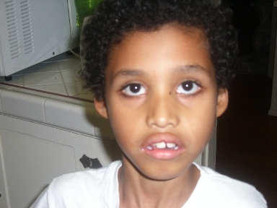  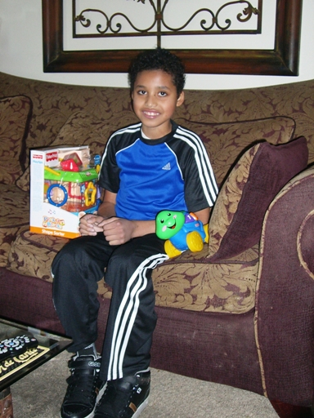  <continued on next page>
503.363-4588 * www.MercyCenters.org 3

* The MERCY News *
<continued from previous page> home could send Joey into an emotional state of chaos. He displayed dangerous behaviors such as hitting, throwing things, and self-injurious behaviors - even running out of the home. “He was a danger to himself and others” Mieko stated.  He was suffering from anxiety, OCD, and aggression since an early age. At the age of 5, Joey was prescribed the first of many ineffective, harmful medications. The medications he was prescribed at that time worked for about a year but, Joey refused to eat and that was the beginning of their story. As a result of the serious side effects, Joey became malnourished and was diagnosed with Anorexia.  Brownie Intervention!  Not knowing what results to expect, at best Mieko was hoping her son would regain his appetite and have the urge to eat after using Medical Marijuana (MMJ). Just accomplishing that would be so many answered prayers. She could have never imagined what would happen next.  Mieko got her first recommended dose discreetly delivered to her home from a local dispensary. She decided on administering it to him in the form of an edible. These are referred to in the Cannabis Community as Medibles. Ingesting edibles you receive much less of the high that you get from smoking or vaporizing, and it seems to remain effective for longer periods of time. Mieko feels this is the most responsible and effective way to administer the treatment to Joey.  Knowing Joey loves chocolate, she and Eric came up with a brownie mix that Joey to this day cannot tell the difference  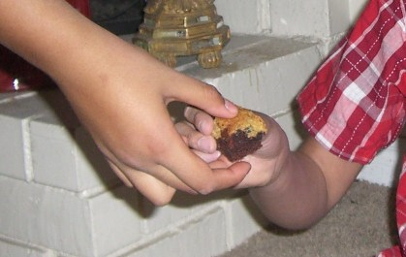  She started off by boiling the MMJ in water. After simmering it, Mieko drained the water and added the MMJ to a stick of butter. She simmered the MMJ in the butter, and then split the butter into 2 | batches. Then she baked the brownies that would forever change their lives.  With his very first dose, Mieko started off small. She portioned out a piece about the size of a quarter. She handed it to Joey and HE ATE IT! “Moms Brownies - Who wouldn’t love them?”  She was initially concerned with Joeys reaction to the taste, but Joey didn’t seem to mind!  She was confident in her decision to treat Joey with MMJ. She was comforted by the fact that no matter what happened, this would not be lethal to Joey - regardless of dosage amount. She knew above all else she was not killing her son! But was he going to start eating?  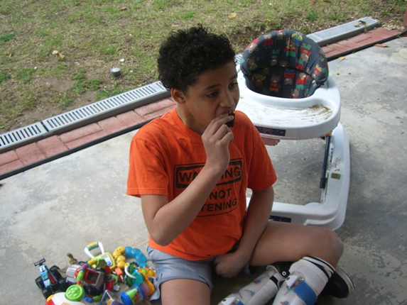  Almost immediately after eating his first brownie, Joey’s mood was calm and relaxed. An uncommon silence filled the house. Just fifteen minutes in, Mieko started witnessing the first of many miracles. Unsure of what she would find, Mieko snuck past Joey’s room to observe his behaviors. She was almost moved to tears with what she witnessed. Joey was quietly playing with a few of his toys. Appropriate play- that just didn’t happen with Joey. He wasn’t throwing them, or hording them, or banging them on the walls. He was calm and at peace, and playing with his toys. It was not a reaction that took a few months to observe, it was immediate improvements, and such an added bonus. But was he going to start eating?  Just one hour after Joey’s first brownie, he started exhibiting signs of hunger. That evening Joey was experimenting with foods he would never try before. He was hungry, and eating. It was a miracle! Something wonderful was happening! He was calm and relaxed, his behavior was appropriate, and he was hungry! They were the kind of results a mother only dreams about and never imagines could happen almost immediately. Joey’s previous medications would take 3-6 months to test the effectiveness, with harmful side effects  <continued on next page>
4 mercycenter@hotmail.com *

Volume 7, Issue 7 * July * 2010
<continued from previous page> the entire time. This was showing to be effective in only the first hour. Without a negative effect so far. Could this be too good to be true?  Joey had a wonderful first day and night on his MMJ treatment. He slept peacefully through the night, and woke up in good spirit’s the next morning. No need for another dose yet as Joey responded amazingly to his first administer dose of Brownie Intervention! Joey does not need to take a daily dose of MMJ. Instead, One dose remains effective in treating him for 3-5 days.  Since the start of his MMJ treatment over Eight months ago, Joey has successfully eliminated the need for almost all his prescription meds. Today, Joey’s weight is stable. His Anorexia has been successfully treated - turning a malnourished, helpless, dying little boy into living proof that Marijuana does have medicinal value, and can be used as an effective treatment for certain children and adults. “THE COMPASSIONATE USE OF MEDICAL MARIJUANA SAVED MY SONS LIFE! Medical Marijuana is an effective medicine” Mieko proclaims.  Joey's MMA dosage versus His ineffective prescription medications  Mieko doesn’t plan on making any changes to Joey’s treatment anytime soon. In his eight months of treatment, she has not witnessed any negative side effects. Joey continues to improve every day.    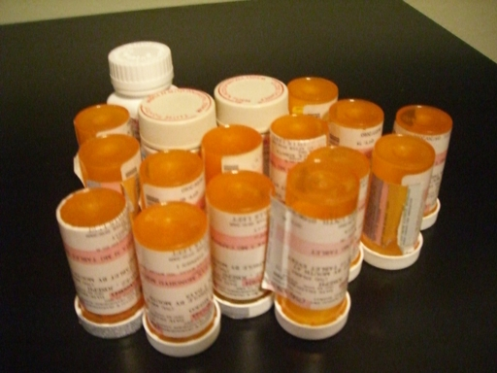 | Since the start of treatment Joey has turned into a new little boy. One full of life, and showing his personality. He is reaching out for social interaction, making eye contact, and even giving out affectionate hugs.  Some of the documented improvements that have been noted by Doctors, Teachers and caregivers include:  *Improved attitude/mood: He is happier now and healthy. He is coming out of his shell and showing his true personality.  *Improved sociability with peers: This behavior is present at school and at home.  *Improved concentration: He is able to focus his attention and work on given tasks.  *Improved sleep pattern: Joey would stay up for weeks at a time. He could not rest comfortably. His sleep was unpredictable. Mieko spent many long nights trying to comfort her son. Now his body is at peace and he comfortably rests through the night.  *Improved receptive and expressive language: This is the first time in Joeys life he has shown improvements in this area. Improvement started to occur immediately after the start of the Medical Marijuana treatment.  *Improved Anxiety, aggression, and appetite: Improvements in these areas were so dramatic that Joey was able to eliminate the ineffective prescription medications he’d currently been using to unsuccessfully treat these conditions.  Joey also suffered with lifelong diarrhea. Nothing was effective for treating this condition. Since the start of the Medical Marijuana, Joey’s bowel movements are normal for the first time ever!  With the elimination of these harmful medications, also comes the elimination of unwanted side effects caused by their use. Since the start of his MMJ treatments and the elimination of certain prescription meds, Joey no longer suffers with Anorexia, Malnutrition, seizures, facial tics or liver damage. He also eliminated the most serious side effect associated with these medications, Death! Of all the evidence that lacks with MMJ, one fact remains undisputed to this day - Joey will never die from his use of Medical Marijuana. That is one fact that can be proven and is backed by 5000 years of documented use. That is one very important and comforting fact! There is not 1 reported death from a marijuana overdose. It can not happen- it is physically impossible!  <continued on next page>
503.363-4588 * www.MercyCenters.org 5

* The MERCY News *
<continued from previous page>  First time for everything  Mieko has been moved to tears more than once since starting Joey on Medical Marijuana. Tears of Joy and excitement, of hope and reassurance that she has made the right decision. Having Joey being on an effective treatment for the first time in his life has made all the difference in the world. Mieko is experiencing new beginnings everyday.  She never thought she would see Joey’s 11th Birthday. Doctors told her Joey would not live that long. We hate to admit that the doctors are sometimes wrong but, Happy 11TH Birthday Joey!  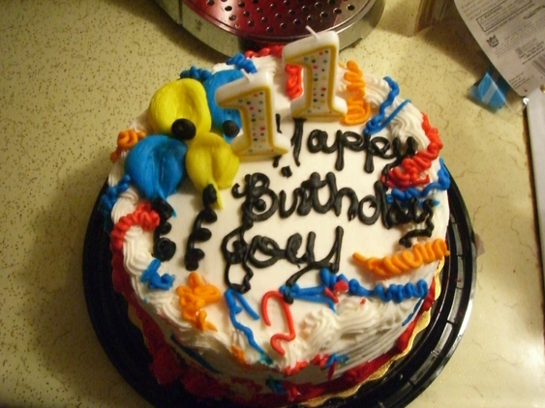  March 1, 2010 Joey enjoyed his 11TH Birthday. This years celebration was like the first one all over again! Joey has shared in many joyous ‘firsts’ with his family since starting the Medical Marijuana treatment. His mother describes it as “An Awakening!”  “The first month we started MMJ – Joey had requested to eat sushi, mind you this was a typical child diagnosed with Autism – he only ate a few items, PB&J – cereal and chicken nuggets.  A few months later his palette was enjoying foods like asparagus, broccoli, Salmon. Also, in that same month we noticed different sounds and sometimes repeating my 1yr old my mimicking Da’da.  My husband Eric caught Joey watching television – Joey has never responded to the TV. We still catch him paying attention to different shows.  We are also noticing Joey’s willingness to share toys with his younger brother, not all the time but we do notice after he has eaten a brownie. | "Priceless Interaction between two brothers. Joey is happy interacting with his brother now. Joey’s reaction to his brothers physical play speaks a thousand words!"  Recently, in the car dancing to the beat of music – was a jaw dropper! My son’s overall well being is peaceful, something we had not seen for a very long time. Joey loves interaction with people, his personality shines now - his eye contact has improved, his demeanor is welcoming and his health is in the 70% percentile – we went from 5% to 70% in Eight months of the use of Medical Marijuana – you can’t deny those results!  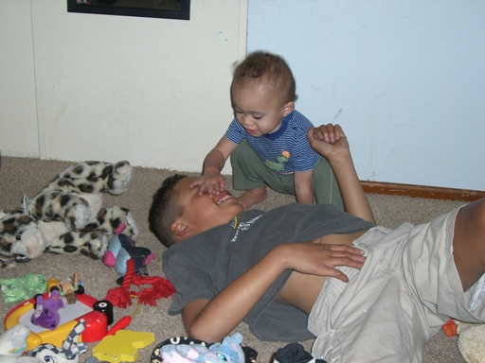  When I lost Joey at 16 months, he was saying “mom” and that’s all I want to hear and even if I don’t hear it – I have my son, thanks to research and the California Compassionate Use Act of 1996.”  Compassionate Caregiver or Criminal?  Medical marijuana laws in California are continually evolving and medical marijuana still remains illegal under federal law.  Under federal law, marijuana is treated like every other controlled substance, such as cocaine and heroin. The federal government places every controlled substance in a schedule, in principle according to its relative potential for abuse and medicinal value. Under the CSA, marijuana is classified as a Schedule I drug, which means that the federal government views marijuana as highly addictive and having no medical value.  The DEA, like local enforcement agencies, can choose how to make the best use of its time. In a perfect world, the DEA would leave medical marijuana patients and their caregivers alone. Federal law does not yet recognize medical marijuana, and the DEA IS currently allowed to use the Controlled Substances Act to arrest people for its use.  Backed by Federal Law and the Controlled Substance Act, Child Protective Services could open  <continued on next page>
6 mercycenter@hotmail.com *

Volume 7, Issue 7 * July * 2010
<continued from previous page> an investigation into Mieko and her family for her choice in using this treatment. They could take Mieko to court  if they feel she is being unfit or putting Joey at risk - as was the case with Debbie Jeffries, of Rocklin, California. Ms. Jeffries was administering Medical Marijuana to her eight year old son under a physician’s recommendation. The use of Medical Marijuana was effectively treating his ADHD. Child Protective Services took Ms Jeffries to court asking the judge to force Ms. Jeffries to stop administering Medical Marijuana to her son. Thankfully, after seeing all the documented improvements in her child since using Medical Marijuana, the judge dismissed the case against Debbie Jeffries - allowing her to continue treating her son.  When I asked Mieko WHY she risks everything to publicly share Joeys story and success this was her response.  “Being in the legal field for over 15 yrs, I have a “black belt” in the “document trail” game…  I have so many agencies in our home documenting our life, it would be impossible for any agency to dispute my decision to use MMJ as a safe and effective treatment for my son.  I am a compassionate care giver, no doubt – In our case I believe this is why the California compassionate use act of 1996 was passed to preserve life.  Our case was to preserve life, an oath taken by every doctor in this country.  In my son’s case his health was well documented and justified for the use of MMJ, I don’t think any agency or professional would of second guess my attempts to keep my son alive and I don’t think the federal government would take the risk prosecuting a mother and losing her son first to Autism, then to medications associated with Autism would be appropriate, that would be like opening up Pandora’s box – Autism is now an epidemic on the rise in every state, race, culture and creed.  For every mother like me there’s 1 out 67 homes in every state dealing with the Autism factor, and I’m sure 65 of those homes are going through medication after medication without seeing any progress. To deny Medical Marijuana as an alternative treatment could end up causing the government bigger problems. I repeat, I’m not worried about what caused Autism – I am more concerned with the quality of life of our children and last time I checked our government had the same goal. Sometimes, in the name of politics we lose site | of our future and if I’m that person…here to remind decision makers about what it means to take an oath to preserve life – I’m ready to take that job on.”  Autism Speaks - Who’s Listening?  After going public with Joey’s story in hopes of helping another family, Mieko started the Unconventional Foundation For Autism.  “I am not a cannabis user. I am in support of the California Compassionate Use Act. I am a mother who has vowed to hold doctors to the Oath they take when they become doctors - To preserve life! Even if that means recommending Medical Marijuana as a safe and effective alternative to our children for parents who have exhausted all other treatments.  When Joey was diagnosed, I had to take a crash course in dealing with agencies and foundations that appeared to help me but, never did! Talk about taking the right path – Thank God it was the legal one… for many years I would master the legal system via school and work and only to find out, I could not attend law school because I now have a child diagnosed with Autism.  Looking back, at all my experiences…I for some reason thought I was the only parent/single mother looking for direction. Still after years had gone by – I had taken the I will just do it myself approach – I remember after calling a very well known foundation only to receive a voicemail, and a generic email asking for a donation so, I called another organization and realized I knew more than the person on the line. At the time, I was a single mother with 2 children working 2 jobs, and near a breakdown. I could not get an organization to provide me with any useful information! It’s now,  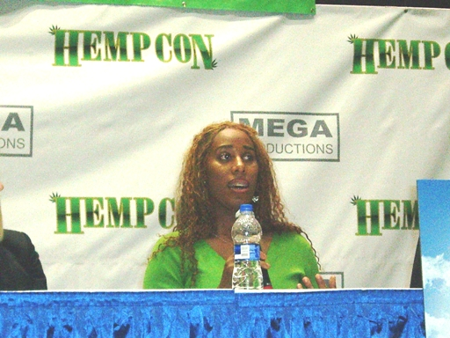  <continued on next page>
503.363-4588 * www.MercyCenters.org 7

* The MERCY News *
<continued from previous page> 2010 and do you know how many emails I receive a week from parents with the same story! I was one of these parents and this is why I started my foundation – everything I have done for my son has been “unconventional” and I vowed to help every mom, dad, grandparent and caregiver that needs my help personally. You see, because I’ve been where these parents have been – I’m not a celebrity, doctor, educator or agenda driven organization – I’m just a mom on a mission to provide my research, our story and remind our country that our future lies in an oath to preserve life no matter the treatment option” Mieko says.  Mieko did an interview with Russ Belville on a NORML radio podcast about their story. On the same interview, she heard Cheryl Shuman speak. “I knew she was on my list of amazing woman I wanted to get in touch with. Mrs. Shuman’s strength was so the new 2010 Super Woman and her cause was very similar to my own. Right after the interview, I sent her an email and she personally responded - I was able to speak with her multiple times and when she called she would ask about Joey. Those really true to this cause know why I’m going public for every Joey out there. Between emails and weekly phone calls asking her for advice and knowing the NORML organization views my voice as an effective role in this movement, The Beverly Hills Chapter of NORML nominated me to be on the board of directors, what an honor. I’m still very new to the industry and it will take some time before I make any decisions on an organization other than my own” Mieko said.  But, it did raise the question where are the Autism organizations that know she is following a bio med protocol set forth by Dr. Bernard Rimland?  “Without Dr. Bernard Rimland’s Unconventional Research I would be planning a funeral for my son”!  DR. Bernard Rimland passed away in 2006. He is still saving lives through his research -“My Son Joey” Mieko says.  Mieko was asked to speak at HempCon in Los Angeles by Ms. Shuman and Fred Rhoades. “I was thrilled and skeptical at the same time – would my image be damaged, would I get thrown under the bus by an Autism organization, I could not make up my mind….down to the day of the press conference. I was visibly in a state of confusion and nervous- this was my first press conference”.  She walked up to the table and sat down. “To my surprise Cheech Marin sits right next to me, camera’s flashing…is this really happening? The first thing Cheech says is “how is Joey doing? Tell me | 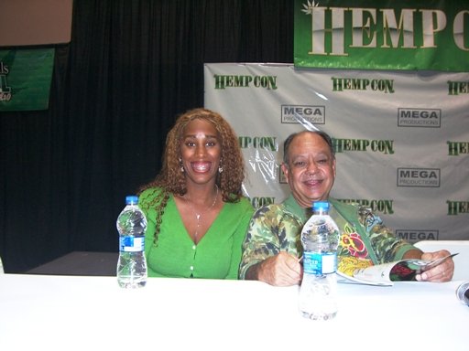  more about Joey” and I opened right up! I suddenly realized – no matter what platform I’m on – Marijuana saved my son’s life! And that’s how I started my speech and it was a hit! Cheech Marin was my inspiration for helping me figure out – I’m still Joey’s mom, with the same story even at HempCon” Mieko stated.  MMJ through a child’s eyes: How I got my brother back.  With everything Mieko was able to accomplish so far, educating our future generation ranks up there with some of the most important things she continues to do. She involved her daughter, Rebecca, with everything concerning Joey. She shared her research discoveries, education, and concerns with her. In return, Rebecca is now educated on Medical Marijuana and shares her experience with all that will listen.  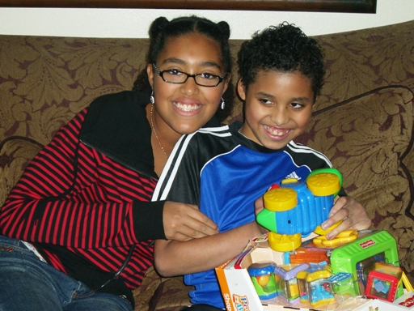  “I have always included Rebecca in on all Joey’s decision making, she’s a part of the team! I shared  <continued on next page>
8 mercycenter@hotmail.com *

Volume 7, Issue 7 * July * 2010
<continued from previous page> Dr. Bernard Rimland’s research and reports as I value her opinion. She may be 12 but, she knows her brother” said Mieko. This is Rebecca’s story.  _____________________________________________________________  Hi, I'm Rebecca, Joey’s Sister, and I'm 12 years old.  Medical Marijuana has done a LOT for my family.  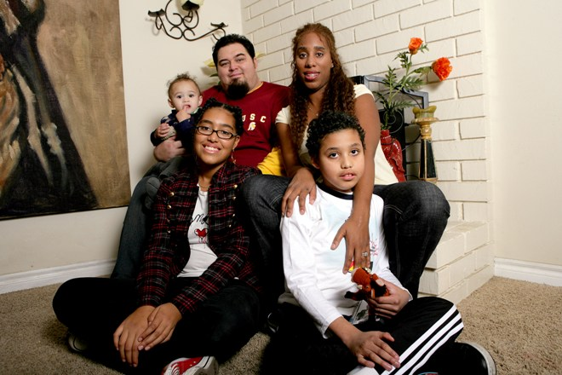  Joey is finally up to regular weight, a better attitude, and behavior. He's just all-around happier, and it’s nice. He's actually playing with me and Diesel. He's making noises and laughing more. He's eating better. He's calmer and (behavior wise) easier to be around. He's a better brother with Medical Marijuana and I'd like it to stay that way.  Oh my goodness. Without Medical Marijuana, it would be just tragic. He wouldn't be around to even celebrate his birthday. He wouldn't be around to bring us joy as he does today. Without this option of MMJ, Joey would be dead and leaving us to never know that it could have been avoided. We also would never show the world that Medical Marijuana is helping people. It... it would be horrible without Joey. I don't even want to think about it.  How did you first learn about Medical Marijuana?  I first learned about Medical Marijuana when my mom said we had to give it to Joey. It was really a surprise thing. I've heard about it before and saw it did great things for other people but, I never knew that Joey would have to use it someday.  How did you feel about your brother starting a treatment using Medical Marijuana?  Oh, I already saw that it helped others and I'm totally for this being given to Joey.  What changes have you seen in your brother since starting the Medical Marijuana treatment? |  |  | I've seen many changes, the hunger and the weight  are really obvious. He's been eating normal and almost always asks for seconds by showing us his empty plate. His behavior is really something to see, he's just calm and content almost all the time. We have to check on him because he's so quiet! But, as soon as we say "Hi" to Joey, he's up and laughing. He's laughing OUT LOUD and its just a beautiful thing to hear. Just 6 months ago, I would of never heard these noises or seen this behavior without MMJ. It just makes me really happy to see him this way.  Did you ever disagree with your brother using Medical Marijuana?  I never disagreed. Why would I? My little brother was DYING. My mom has always included me in. Have you ever been faced with a negative response to what your Mom is doing? Ah, yes. At school.  How would you defend your Moms decision to someone if you are ever faced with a negative response?  I was talking about it and this guy just randomly came out of nowhere and said "Hah, he's stoned." I almost punched him in the head for saying that. I explained that he has Autism and MMJ affects him differently. He also apparently thought he was smoking it. Joey has Autism, how could he smoke it? I, of course, also explained that he was eating it in brownies. My friend then became choked up a little after I told him Joey was dying. I mean, how can you argue with pure, real facts?  Do your friends at school know about this? If so, What do they think about it?  Yeah, they know. I've been talking about it ever since it happened. They think its OK. It's not really something that kids, 11-15 years old, really care about. I do have some friends who care. They're awesome!  Do you know what the Compassion Act is?  The Compassionate Use Act is the act of using Medical Marijuana legally.  Are you aware that Medical Marijuana is not an available option to some kids just like your brother - Just because of the state they live in?  Yes, I am. I know there's 14 states that can use it legally and that we have 36 more states to go. We need to get it legal in all states, What if someone in, lets say Idaho, has Autism, needs to gain weight  <continued on next page>
503.363-4588 * www.MercyCenters.org 9
 | * The MERCY News *
 |  | <continued from previous page> and on the verge of dying within 6-7 months? MEDICAL MARIJUANA. It would seriously help.  How does that make you feel?  It makes me feel like someone that needs it is just dyeing right now. In dire need of MMJ and on the verge of their last breath. If there's a will, there's a way.  Do you understand what your Mom is doing right now?  My mom is working hard to help other parents get the option to use of MMJ in every state for children similar to Joey and to help families see what we are seeing in our home.  Do you understand the purpose of the Unconventional Foundation 4 Autism?  Yup, Uf4a is the website showing about Joey and her plan to legalize MMJ for every state, for medical use with children diagnosed with autism.  Do you ever think about joining your Mom on her journey spreading Joeys story?  Of course! I'd love to join my mom, she’s my hero. But, I think graduating middle school, then high school, then college are my mom’s priorities for me right now.  _____________________________________________________________  What do the Doctors say?  Bernard Rimland, PhD, of the Autism Research Institute, stated in a 2003 article published in Autism Review International:  "Clearly, medical marijuana is not a drug to be administered lightly. But compare its side effects to the known effects of Risperdal, which include massive weight gain, a dramatically increased risk of diabetes, and an elevated risk of deadly heart problems, as well as a host of other major and minor problems.  Other psychotropic drugs are no safer, causing symptoms ranging from debilitating tardive dyskinesia to life-threatening malignant hyperthermia or sudden cardiac arrest.  Of all drugs, the psychotropic drugs are among the least useful and most dangerous, and the benefit/risk profile of medical marijuana seems fairly benign in comparison.  Moreover, the reports we are seeing from parents indicate that medical marijuana often works when no other treatments, drug or non-drug, have helped."  David Hadorn, MD, PhD, Medical Consultant at GW |  | Pharmaceuticals, Ltd., wrote in his document "Use of Cannabis Medicines in Clinical Practice," published July 17, 2003 on his former website:  "Available evidence from culture in which children are provided with cannabis [marijuana] for therapeutic purposes (e.g., Jamaica) has failed to detect any specific adverse effects from such use.  Moreover, there is powerful anecdotal evidence that some children with hyperactivity or aggressiveness can benefit substantially from cannabis medicines (in non-smoked forms).  When used in small doses as directed, cannabis is a much milder drug than Ritalin or many of the other powerful psychotropic agents commonly prescribed for such children these days. Also, one study found that a cannabinoid (delta-8 THC) was safe and effective for treatment of nausea and anorexia due to cancer chemotherapy in children."  Peter A. Clark, PhD, John McShain Chair in Ethics at Saint Joseph's University, wrote the following in his afterward for the Apr. 2003 book Jeffrey's Journey by Debbie and LaRayne Jeffries, in which giving medical marijuana to an 8-year old is discussed.  "The issue in this case is whether or not it is legal and ethical for a parent/surrogate to give consent for a minor to use medical marijuana, which the federal government maintains is unproven in terms of safety and efficacy and could be a 'gateway drug' that leads to more serious drug use...  Seriously ill patients, both adults and minors, have the right to effective therapies. To deny them access to such therapies is to deny them the dignity and respect all persons deserve. [The child's] mother is certainly acting in his best interest.  The benefits of the current treatment outweigh the burdens. No other medication or therapy has been as effective as the use of medical marijuana in relieving his pain and suffering."  Jay Cavanaugh, PhD, National Director of the American Alliance for Medical Cannabis, wrote the following in his Sep. 2002 article "For the Sake of the Children," published on the website of the American Association of Medical Cannabis: "Cannabis can provide unique help with some childhood disorders including cancer but also attention deficit disorder and autism.  These latter disorders are currently treated with powerful stimulants such as amphetamine in the first case and with brain numbing toxic preparations such as Haldol in the case of autism....  <continued on next page>
 | 10 mercycenter@hotmail.com *

Volume 7, Issue 7 * July * 2010
<continued from previous page> Imagine a child being given half a dozen psychotropic drugs from Prozac to Haldol to Valium and who continues to break down doors and assault others seemingly without provocation who now responds to therapy with medical cannabis. Imagine the parents of such children contemplating a lock up for their beloved child who now sees that child calm and functional.  Loving parents will demand that cannabis be provided to the arsenal their pediatricians and pediatric neurologists already have.  The message to our sick and suffering children is that we love them. The love is greater than any blind acceptance of the existing wrongful beliefs about cannabis that are merely the propaganda of cultural elitists.  As loving parents, these folks are willing to risk the wrath of Child Protective Services, the actions of the DEA [Drug Enforcement Administration], and the ignorance of their own physicians."  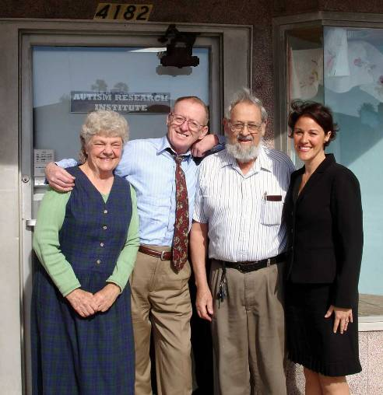  Lynn Zimmer, PhD, Former Professor Emeritus at Queens College at the City University of New York (CUNY), wrote in his 1997 book Marijuana Myths, Marijuana Facts:  "There is no convincing evidence that marijuana causes psychological damage or mental illness in either teenagers or adults...  For twenty-five years, researchers have searched for a marijuana-induced amotivational syndrome and have failed to find it.... Among high school students, heavy marijuana use is associated with school failure, but school failure usually comes first." | BUT - What’s being published?  The Institute of Medicine published in its Mar. 1999 report titled "Marijuana and Medicine: Assessing the Science Base":  "Adolescents, especially troubled ones, and people with psychiatric disorders (including substance abuse) appear to be more likely than the general population to become dependent on marijuana."  The Eagle Forum notes in its brochure "Facts You Need To Know About Marijuana," from the Eagle Forum website (accessed Mar. 2, 2006):  "Most pot smokers drink alcohol heavily, and may become so confused that they take cocaine or heroin.  When a teenage consumes excessive alcohol, he normally gets sick and vomits. However, THC stops nausea, and so a regular pot smoker can hold down a deadly dose of alcohol without getting sick.  Therefore, the basic cause of teenage alcohol overdose is marijuana....  Medical evidence has proven that marijuana is highly dangerous, in and of itself... Teenagers are particularly vulnerable, because pot smoking can delay and even halt the process of sexual development."  John P. Walters, Director of the Office of National Drug Control Policy (ONDCP), wrote the following in an OpEd published in the National Review on Sep. 27, 2004:  "For youth, the harmful effects of marijuana use now exceed those of all other drugs combined.  Remarkably, over 40 percent of youths who are current marijuana smokers meet the criteria for abuse or dependency. In several states, marijuana smoking exceeds tobacco smoking among young people, while marijuana has become more important than alcohol as a factor in treatment for teenagers."  Glen Hanson, DDS, PhD, Associate Director of the National Institute on Drug Abuse (NIDA), stated on July 10, 2003 during a marijuana briefing in Salt Lake City arranged by the Office of National Drug Control Policy (ONDCP), as reported in the Deseret News:  "Its [marijuana] effects on the brain function are compounded in adolescents because the behavior center at the frontal cortex is literally not developed...  <continued on next page>
503.363-4588 * www.MercyCenters.org 11
* The MERCY News *
<continued from previous page> "To use [marijuana] is to take chemical shortcuts to the brain's pleasure center. It is not like riding a roller coaster or jumping out of an airplane. This is adding chemicals to your brain, not inducing a normal sensation. You are changing the way it normally functions and, in effect, creating a mental disorder. The brain bounces and bounces and finally stops bouncing back to normal."  Addiction published a Sep. 2002 article, "Cannabis Use and Psychosocial Adjustment in Adolescence and Young Adulthood," which stated:  "Cannabis use, and particularly regular or heavy use, was associated with increased rates of a range of adjustment problems in adolescence / young adulthood -- other illicit drug use, crime, depression and suicidal behaviors -- with these adverse effects being most evident for school aged regular users.  The findings reinforce public health concerns about minimizing the use of cannabis among school-aged populations."  Biological Psychiatry stated in its May 15, 2005 article "Moderation of the Effect of Adolescent-Onset Cannabis Use on Adult Psychosis by a Functional Polymorphism in the Catechol-O-Methyltransferase Gene: Longitudinal Evidence of a Gene X Environment Interaction" by Avshalom Caspi and Terrie E. Moffitt, et al.:  "Recent evidence documents that cannabis use by young people is a modest statistical risk factor for psychotic symptoms in adulthood, such as hallucinations and delusions, as well as clinically significant schizophrenia. The vast majority of cannabis users do not develop psychosis, however, prompting us to hypothesize that some people are genetically vulnerable to the deleterious effects of cannabis.  In a longitudinal study of a representative birth cohort followed to adulthood, we tested why cannabis use is associated with the emergence of psychosis in a minority of users, but not in others."  What the future holds for Mieko Hester-Perez & the Unconventional Foundation for Autism  Since starting the Unconventional Foundation 4 Autism, Mieko has traveled to Wisconsin at the request of parents and caretakers of special needs children. She was a guest at the THC Expo where she shared Joeys success story to Kevin St. John, Special Assistant Attorney General for Public Affairs | and Policy. Mieko informed him parents in his state contacted her to come help pass the Jacki Rickert Act for compassionate use of Medical marijuana.  Mieko is also planning a trip to Rhode Island this year. She has been asked by ‘Americans for Safe Access’ to share Joey’s story of success at the Patience Conference in April.  “We are at the forefront of Healthcare reform & The Unconventional Foundation for Autism has a mom that never settles; my goal is to make sure another family does not endure what I have gone through but to empower every home nationwide with the TOOLS that have helped me become a better advocate for my son.  Autism has made me be better parent, and Joey has shown me who I really am when I look in the mirror - His mother, His legal counsel and His RESEARCH TEAM!  Through the use of our website, WWW.UF4A.Org, I will be able to provide my experiences based off my "crash course" with medical professionals, special Education Laws (IDEA), handy tips for dealing with school districts, and knowing when to use an attorney. There will be no child left behind at The Unconventional Foundation for Autism!” Mieko Hester-Perez 20/20 ABC has been following Joey and his family during his Medical Marijuana treatment and will air their journey June 2010, check your local station for the air date. TBA  Mieko is currently working on the completion of her book, “A Mother’s fight to save her son’s life”.  Spectrum Magazine Publication will be sharing Joey’s journey in the June 2010 Issue.  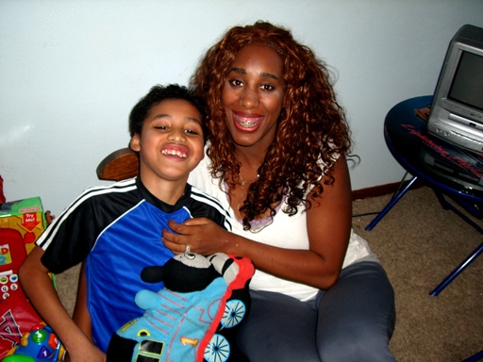  <continued on next page>
12 mercycenter@hotmail.com *
Volume 7, Issue 7 * July * 2010
<continued from previous page> So, what can you do to help Mieko’s foundation continue to spread Joeys successful treatment and the importance of this safe option - for children EVERYWHERE?  “I only ask, If you believe in me and my foundation donate to keep me going, If you believe I make a difference…donate. If believe your state should hear my story…donate. If you believe having Medical Marijuana as an option for your child is worth me fighting for…donate. And If I haven’t done all the things you have asked of me – I will personally REFUND your donation! How many foundations do that?? I am Joey’s Mom, and Executive Director of The Unconventional Foundation for Autism (UF4A).“ Contact - The Unconventional Foundation for Autism at Mailing Address: 205 S Broadway, #202, Los Angeles, CA, by Phone: (213) 482-1010, or fax: (213) 482-1011, or visit - http://www.uf4a.org/ For more on the story, go to the Source - http://compassionassociates.org/home/1-compassion-associates/124-joeys-journey-medical-marijuana-sav  _____________________________________________________________  Pro’s Vs Con= Medical Marijuana Compared To Conventional Medications For Children With Special Needs  PRO: Effectiveness- Testing the effectiveness of Medical Marijuana can be achieved in as little as an hour, compared to the typical 3 months recommended for many prescription medications. Effects of Medical Marijuana (depending on how administered, and dosage amount) can last anywhere from hours to days. This eliminates the strict, daily dosing associated with prescription medications. With Medical Marijuana, negative effects are minimal - no serious, life threatening side effects have ever been reported or proven to be caused from Marijuana use. While the possibility of death is a rare side effect in most of these prescription medications, the possibility of death as a side effect of Medical Marijuana is ZERO. Medical Marijuana is Non-toxic. Medical Marijuana will never damage your liver or kidneys. Liver damage and kidney failure is a known side effect in almost all the conventional medications offered to children diagnosed with Autism or ADHD.  Flexibility- With prescription medications, they must be administer on a regular basis. Skipping doses can cause unwanted side effects, and in some cases dangerous withdraw symptoms will occur. Irregular dosing can make the medication ineffective, leaving you with unwanted side effects instead of treatment. Medical Marijuana on the other hand is a very flexible treatment option and can be | used on an as needed basis. Doses of MMJ can be skipped with no ill effects or any physical signs of withdraws. Medical Marijuana can be easily, and safely increased as needed.  Tolerance buildup - By rotating different strains you can eliminate the chance of ever building up a tolerance to Medical Marijuana. If one strain starts to become ineffective, instead of increasing the dosage amount, you can just switch strains. The Medical Marijuana remains effective as the results from your next strain in rotation will be seen immediately after first dose. This is not an option with prescription medications. Prescription medications are just increased in dosage amount until the child is taking a maximum dose that is no longer effective in treating their symptoms. Once the child’s dose has been increased to the maximum amount ( often adult doses) they will be switched to a different prescription. New medications can take up to 3-6 months to test the effectiveness. Starting a vicious cycle of ineffective treatments that your child will eventually build up a tolerance to - all over again.  Cost efficient - Prescription medications are costly, and some are not covered by certain medical insurance providers. There is no option to grow/produce them yourself. Conventional and alternative treatments can range from hundreds to thousands of dollars per treatment. However, if grew indoors, a typical Medical Marijuana treatment for a child would cost under $1.00 a day. If grew outdoors, in just one season you could produce enough Medical Marijuana to last a child for an entire year. Produced outdoors, Medical Marijuana’s cost per pound would compare to the price of common garden vegetables.  Nature-al Experience - Helping tend to their own medicinal garden will help children experience real world examples and experiences that boost learning for special needs children who thrive on practical instruction. All activities in the garden may not be skill appropriate but can be adjusted to the child’s ability to participate. This experience can allow children to connect with nature and their care takers in unique and important ways. Helping tend to their medicinal garden will provide a hands - on experience that allows children to see cause - and - effect relationships. Tending plants helps children develop patience, responsibility, and self confidence. Garden activities provide opportunities for sensory exploration, the expression of creativity, and practice of inquiry. The physical nature of gardening especially engages children who have trouble sitting still and concentrating. Garden work helps to build gross and fine motor skills which can decrease  <continued on next page>
503.363-4588 * www.MercyCenters.org 13
* The MERCY News *
<continued from previous page> stress. Gardening skills can translate into job skills later in life or become a life long hobby.  CON: Illegal - Marijuana for ANY reason is illegal under federal law. Many people are confused about the legality of Medical Marijuana. Even in a state that has legalized the medical use of marijuana, it is still illegal according to the federal law. In the case of a conflict, federal law supersedes state law.  _____________________________________________________________  <continued from CRIME OF THE CENTURY, page 1 > cultivation permit program. Greenfield even had county-issued "zip-ties" on her plants designating their legality under state and local law. Then, on July 9th, the DEA conducted multiple raids on medical marijuana dispensaries in the San Diego area, arresting 12 people. Among other items seized in the raids, the DEA took money, medical marijuana and cultivation equipment, as well as financial and private patient records.  "Patients are fed up with platitudes and half promises from the Obama Administration," said Eugene Davidovich of the San Diego chapter of Americans for Safe Access. "We're here at the federal courthouse to vocally oppose continued attempts to subvert state law, and to push for a federal policy that actually protects patients in this country."  John Roberts, who was well below the legal limit as a caregiver in Michigan, produced oil-based medical marijuana that was used by seriously ill patients, including a 6-year-old girl with brain cancer. The young girl, who because of the DEA raid will now go without her medication, successfully used the oil to treat her headaches, to help her sleep, and as an appetite stimulant. Roberts had held a protest less than a week before the July 6th DEA raid to bring attention to ongoing law enforcement harassment of patients in the Saginaw area.  The most recent federal raids and subsequent protests come as Acting DEA Administrator Michele Leonhart is preparing to be confirmed by the Senate Judiciary Committee. Leonhart is a Bush Administration appointee who was Deputy Administrator under then-DEA Administrator Karen Tandy. Both were responsible for more than 200 raids in California and other medical marijuana states during the Bush Presidency. In her capacity as Acting Administrator, Leonhart also moved to block medical marijuana research in January of this year by refusing to grant an application that would | have expanded therapeutic studies in the U.S. Visit-  http://www.commondreams.org/newswire/2010/07/21-15 - for more.  _____________________________________________________________  <continued from NEW TREND, page 1 > on Good Morning America, tried the drug to treat their son's autism, and met with success - a surprise to many.  Mendoza has been subjected to judgment by others as they learn of her decision to treat Ryan with medical marijuana, she said. She says that if they know how severe Ryan's illness is, some would feel differently. Her son ingests the marijuana either in foods (sold at dispensaries or made at home) or through a tincture - a liquid form of the drug absorbed under the tongue. Smoking the drug is not recommended for children, contrary to what a recent Parenting Fail of the Week demonstrated.  Ryan Mendoza made tremendous strides immediately after his first dose, as his mother wrote on her website that she has been using the site to chronicle her parenting experiences. The boy had been refusing to go to the beach for more than a year, terrified a tsunami would hit, Mendoza wrote. Right after the day after he took the medicinal marijuana for the first time, the family went to the beach and, like any ordinary 12-year-old, Ryan allowed his family to bury him up to his face in sand, his mother wrote. It was a joyous day realized with the help of medical marijuana, his mother explained.  Marijuana is still classified as an illegal drug, and has not been subjected to any double-blind medical studies to prove its effectiveness in treating OCD, autism or anything outside of the spectrum from which it is normally prescribed. The effects marijuana has on the developing brain are not yet fully known, and women are advised not to use marijuana when they are pregnant or breastfeeding. Dr. Lester Grispoon, author of several books relating to marijuana studies, retired physician and professor at Harvard Medical School, has a different take on the effects of marijuana:  "We have been brainwashed about this substance," he said. "There will come a time when people will recognize this as the wonder drug of our times." He adds further, "the most dangerous thing about marijuana just may be the stigma attached to it."  Proponents of medical marijuana also argue that parents treat their kids chronic ailments with harmful drugs without realizing it.  <continued on next page>
14 mercycenter@hotmail.com *
Volume 7, Issue 7 * July * 2010
<continued from previous page> Adderall, a drug to treat ADHD (attention deficit hyperactivity disorder) contains methamphetamine, which is an illicit street drug. Ritalin, also used to treat ADHD, contains methylphendiate - a derivative of methamphetamine as well. As part of the illegal prescription drug abuse pandemic, these drugs are often abused by people without ADHD to achieve a high by either snorting or ingestion.  Autism is commonly treated with anti-depressants (SSRIs), which work to address specific behavioral issues. Anti-depressants have adverse side effects such as nausea, vomiting, hallucinations and a risk of suicide in younger children. Anti-psychotics such as Zyprexa or Haldol are often combined with SSRIs to form a "cocktail" to manage autistic, ADHD or OCD behavior in children. As such pharmaceutical companies have often been the target of advocates for holistic, alternative and plant-based therapies. The cost of treatment with traditional pharmaceuticals can be astronomical for a family.  A small legion of physicians in California are recommending medical marijuana for kids, though the children are older (aged 14 to 18). Like any other controlled substance, children must have a parent accompany them to procure the drug (at a local dispensary). This aligns with the possibility of fully legalized marijuana in the state, which is up for a vote in November 2010.  The state of Oregon currently does not have marijuana dispensaries, but rather an arrangement for patients to grow their own or to buy from caregiver that has four or fewer patients. Dispensaries may come to the state soon, with Measure 28 (which would allow state-licensed medical marijuana dispensaries to sell cannabis) going on the November 2010 ballot. Medical marijuana has been legal in Oregon since 1998.  Even V.A. (Veterans Affairs) hospitals for are easing restrictions on the use of medical marijuana. A new Department of Veterans Affairs policy will go into effect next week allowing patients in its hospitals and clinics to use medical marijuana in states where it is legal. V.A. doctors will still not be able to prescribe medical marijuana, but patients who use it will no longer lose their access to other pain medication - a huge shift in policy.  While Judy Mendoza is publicly advocating for the plant-based therapy for kids, she explains that medical marijuana is definitely not a cure-all:  "Medical marijuana is just a piece of the puzzle. It's almost like a Band-Aid," she said. "I give him such a small amount. It's really just giving them medicine | to treat a symptom." She adds: "It's like [the medical marijuana] just takes the edge off of his OCD. ... It's not like the OCD goes away when he has his medicine, but his ability to cope with it changes." Source - July 25, 11:50 AMMedford Parenting ExaminerValerie Powers, Visit - http://www.examiner.com/x-15109-Medford-Parenting-Examiner~y2010m7d25-Medical-marijuana-for-children-New-trend-in-alternative-medicine  _____________________________________________________________  Recipe For Trouble, Is It A Crime To Give A Child Marijuana To Control Violent Outbursts? - By Mary Jayne McKay  (CBS) Debbie Jeffries of Rocklin, Calif., and her mother, Lorraine, love to cook. Lorraine has even published a cookbook, "50 Years Of Our Favorite Family Recipes."  But what they are whipping up these days isn’t in your average cookbook, reports 48 Hours correspondent Harold Dow. They’re making marijuana - medical marijuana - for Debbie’s son, Jeff.  Using marijuana as a medicine is not unusual in California. Five years ago, voters passed a law allowing patients with serious illnesses, such as AIDS and cancer, to use marijuana for pain, if a doctor approves. But this case is unusual because the patient is 8 years old.  "Jeff has been diagnosed with attention deficit hyperactivity disorder, which is ADHD; oppositional defiant disorder; conduct disorder; intermittent explosive disorder; bipolar disorder - any disorder you can think of," says Debbie, a single mother.  The disorders often lead Jeff to violent, uncontrollable outbursts.  "We’ve had to call the police," Debbie says. "I have woken up to a knife in my back. He used to stab the dogs next door. The teachers were afraid of Jeffrey. He picked up a chair and threw it at a teacher."  Doctors first started Jeffrey on Ritalin at age 3 and began adding other medications over the years, as nothing seemed to stop the outbursts.  "He was a walking pharmaceutical lab," Debbie says. "It was incredible. And nothing was working."  Debbie grew desperate last May when officials issued a deadline: Get Jeff under control in 30 days, or he would be placed under the care of the county.  <continued on next page>
503.363-4588 * www.MercyCenters.org 15


<continued from IS IT A CRIME TO GIVE A CHILD MARIJUANA TO CONTROL VIOLENT OUTBURSTS?, previous page> That led her to an Internet article on how marijuana calms the brain and to Dr. Mike Alkalay, a pediatrician who believes in the medical powers of the drug marijuana.  "This medication has been around for 5,000 years," Alkalay says. "It's basically a Chinese herbal plant that's been used in the Middle East. It's been used in India. It's a very safe medication."  Alkalay admits 8-year-old Jeff isn’t the typical patient to receive marijuana but agreed, without seeing him, to recommend Jeff take the drug.  The decision to try marijuana shocked Debbie’s parents, Ken and Lorraine.  "There was absolutely no way I was for it," says Ken, who describes himself as a conservative. Lorraine adds, "It caused quite a bit of strife in our household."  The results were immediate.  "Within a half hour," Debbie says, "I looked over at Jeffrey, and he just had this smile about him, this glow, and he said, 'Mommy, I feel happy.' And that’s the first time that he’s ever said that."  Just how the marijuana is helping Jeff is not completely clear. "His brainwaves don't connect the way ours do," Debbie says of her son. "The marijuana is allowing him, somehow. It's filling in the gap in there for him, so he is learning how to manage his anger."  But Child Protective Services had a different opinion, and they opened an investigation. Debbie says they are accusing her of being an unfit mother and putting her son at risk.  Part of the problem is that Dr. Alkalay never saw Jeff before prescribing him the marijuana. The doctor says he was comfortable with that because "I know it's a very safe medication."  Child Protective Services is taking Debbie to court where a judge could stop Debbie from giving marijuana to her son. If that happens, Debbie says she won’t be able to control him, and will lose her | son to the custody of the state.  "I’m not a criminal," says Debbie. "I’m a mother who cares for her child and will do anything to help her child."  In just under an hour at a closed-session juvenile court hearing, the judge dismissed the case against Debbie.  "I can’t even express how excited I am," she says. "It's been proven that what I'm doing to Jeffrey isn't a crime."  The decision to allow a child like Jeff access to medical marijuana may have far-reaching consequences.  "It opens up a whole door for parents who have been through what I've been through," says Debbie. Visit - http://www.cbsnews.com/stories/2002/03/05/48hours/main503022.shtml - for more.  _____________________________________________________________  Study: Teens Turn to Marijuana in Lieu of Prescription Drugs  (April 28, 2009) Some teenagers are smoking marijuana for its medical benefits and not to get high, using the drug to self-medicate for conditions like depression, sleep problems, anxiety, stress, pain, and problems with concentration, HealthDay News reported April 23.  Researchers who interviewed 63 adolescents who were regular users of marijuana found that about one-third said they used the drug for medical purposes. "Youth who reported they had been prescribed drugs such as Ritalin, Prozac or sleeping pills stopped using them because they did not like how these drugs made them feel or found them ineffective," according to the study authors. "For these kids, the purpose of smoking marijuana was not specifically about getting high or stoned."  Some adolescents said marijuana provided immediate relief that prescription medications did not. The study appears in the April 22, 2009 issue of the journal Substance Abuse Treatment, Prevention and Policy. Visit - http://www.jointogether.org/news/research/summaries/2008/study-teens-turn-to.html
* The MERCY News > mercycenter@hotmail.com > (503) 363-4588 < www.MercyCenters.org *

